A History of the Dover Gardens Kennel & Obedience Club

The First Thirty Years

Beth M. Robertson

The Dover Gardens Club started classes on Sunday 16 March 1969. The club's founders were Betty and Peter McMonagle of Oaklands Park, Jim and Sadie Richardson of Glenelg North, John and Rosemary Fitzgerald of Hackham and Dave and Dot Rootes of Christies Beach. The key figures in the club's establishment were Betty McMonagle and Jim Richardson.

Betty McMonagle was training her first dog at the South Australian Obedience Dog Club in Adelaide's South Parklands. 'Kym' was a German Shepherd that Peter had rescued as a puppy. He had already achieved his Companion Dog Excellent title in trials and they were working towards his Utility Dog title, the highest standard in obedience. Betty had become an instructor with SAODC but also wanted to help people in her neighbourhood who could not travel to the city to train their dogs.

The Richardsons had recently begun breeding German Shepherds under the 'Glenbonnie' prefix. Jim was training their stud dog, an Australian Champion in the show ring, with the Southern Districts Kennel and Obedience Club at Christies Beach. The couples met during 1968 when Jim began entering his dog in Novice trials to gain his Companion Dog title. Both couples were post-war migrants from Scotland, and they became friends when the McMonagles decided to buy a Glenbonnie puppy.

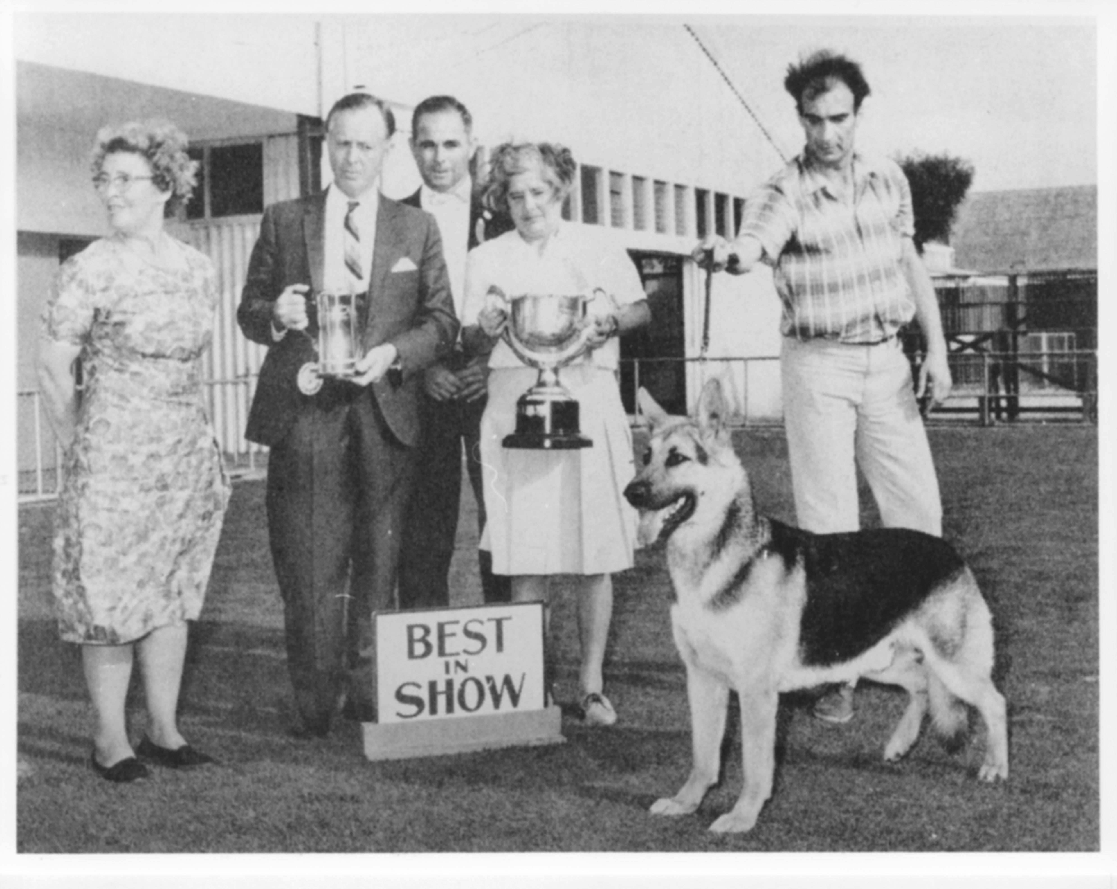
Club Founder Jim Richardson (right) handled other people’s dogs in the show ring while he was establishing his own German Shepherd kennel in the mid to late 1960s. Here he is handling Rowanscourt Gay Cavalier for Mrs E. Hunter at the 1967 Colomeke Kennel Club.

By all accounts Jim Richardson was a very forthright individual and a clash of personalities had developed at the Southern Districts Club. The Fitzgeralds, training a Labrador, and the Rootes, training a Shepherd, were also members of Southern Districts. When Jim Richardson left that club at the end of 1968 they went with him to help the McMonagles start a new dog club in their local area.

Betty wrote to the Marion Council asking for a reserve to use on Sundays and the Council provided the Crown Street Reserve at the cost of $1.00 a week. The new club took its name from the location of the reserve - Dover Gardens. With Jim Richardson as President and Betty McMonagle as Head Instructor, the four couples formed the first committee and team of instructors. It was only the second all-breeds dog club in the rapidly developing southern suburbs, and by word of mouth and a little advertising it had a thriving membership within a few weeks.

Over the years hundreds of volunteers like the founders have helped many thousands of people to train their dogs at the Dover Gardens Club. However, for the first 25 years the club provided this community service without the excellent facilities and long term tenure that it now enjoys at the Mitchell Park Sports Reserve. The club operated at four different locations and used tin sheds, school rooms and even trailers as offices and equipment stores.

As the club out-grew the Crown Street Reserve, the committee learned how difficult it is for an established suburban dog club to get access to suitable grounds. Committee members investigated over a dozen sites before negotiating a lease on a vacant block next to the Suneden Special School in McInerney Avenue, Mitchell Park. The club's storage shed was moved to the site in December 1974. Over the next two years members, now numbering over 300 a year, helped at working bees to improve the grounds.

When the Suneden School gave notice of its own plans for the site, the committee renewed negotiations with Marion Council for permanent grounds. In August 1976 the club was delighted to be offered a lease on spacious grounds in the Oaklands Reserve behind the Road Safety Instruction Centre off Oaklands Road. The club moved to the site during the Christmas break.

The Dover Gardens Club remained at Oaklands Reserve for almost 15 years. Nevertheless, the club's tenure was sometimes uncertain and the committee's efforts to gain permission to build clubrooms was repeatedly frustrated. Then disaster struck. On 27 February 1991 the club's shed and all of its equipment were destroyed in a fire lit by vandals.

For the next two years the club operated at the Forbes Primary School in Plympton South, while the committee worked to replace its losses and, once again, secure the club's future. Various alternatives were being investigated when the Council suggested that the club might be able to join other sporting groups using the facilities at the Mitchell Park Oval.
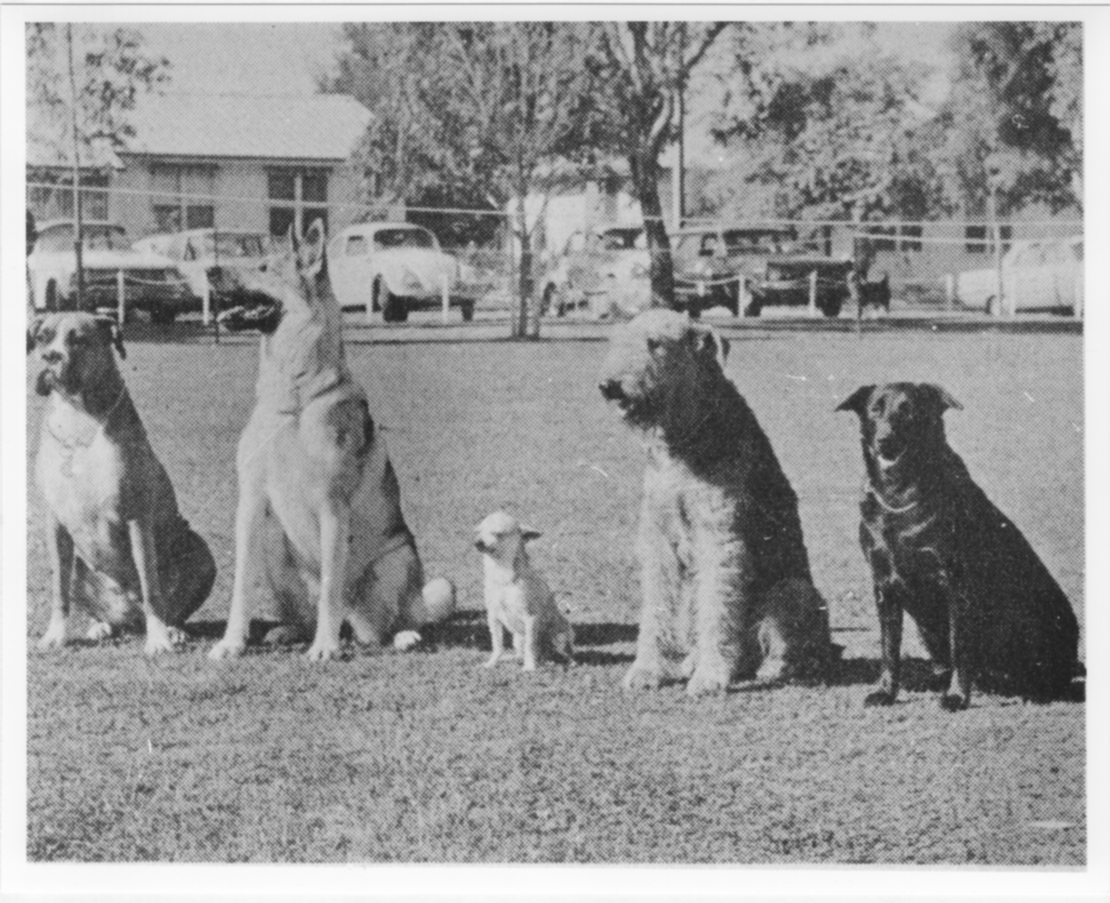
Members’ dogs at the Crown Street Reserve, the Club's first grounds, 1972. The Chihuahua, Joan Tilley’s Callemondah Adam (‘Tyke’), was the first in South Australia to gain a Companion Dog title. The Boxer is Eddie Simpson’s Sally.

After careful consideration, the committee decided that 'Dover' had at last found its home and began spending the hard-earned building fund on improvements to the hall and grounds. Training began at Mitchell Park in July 1993 and the club's annual membership peaked at 754 in 1995.

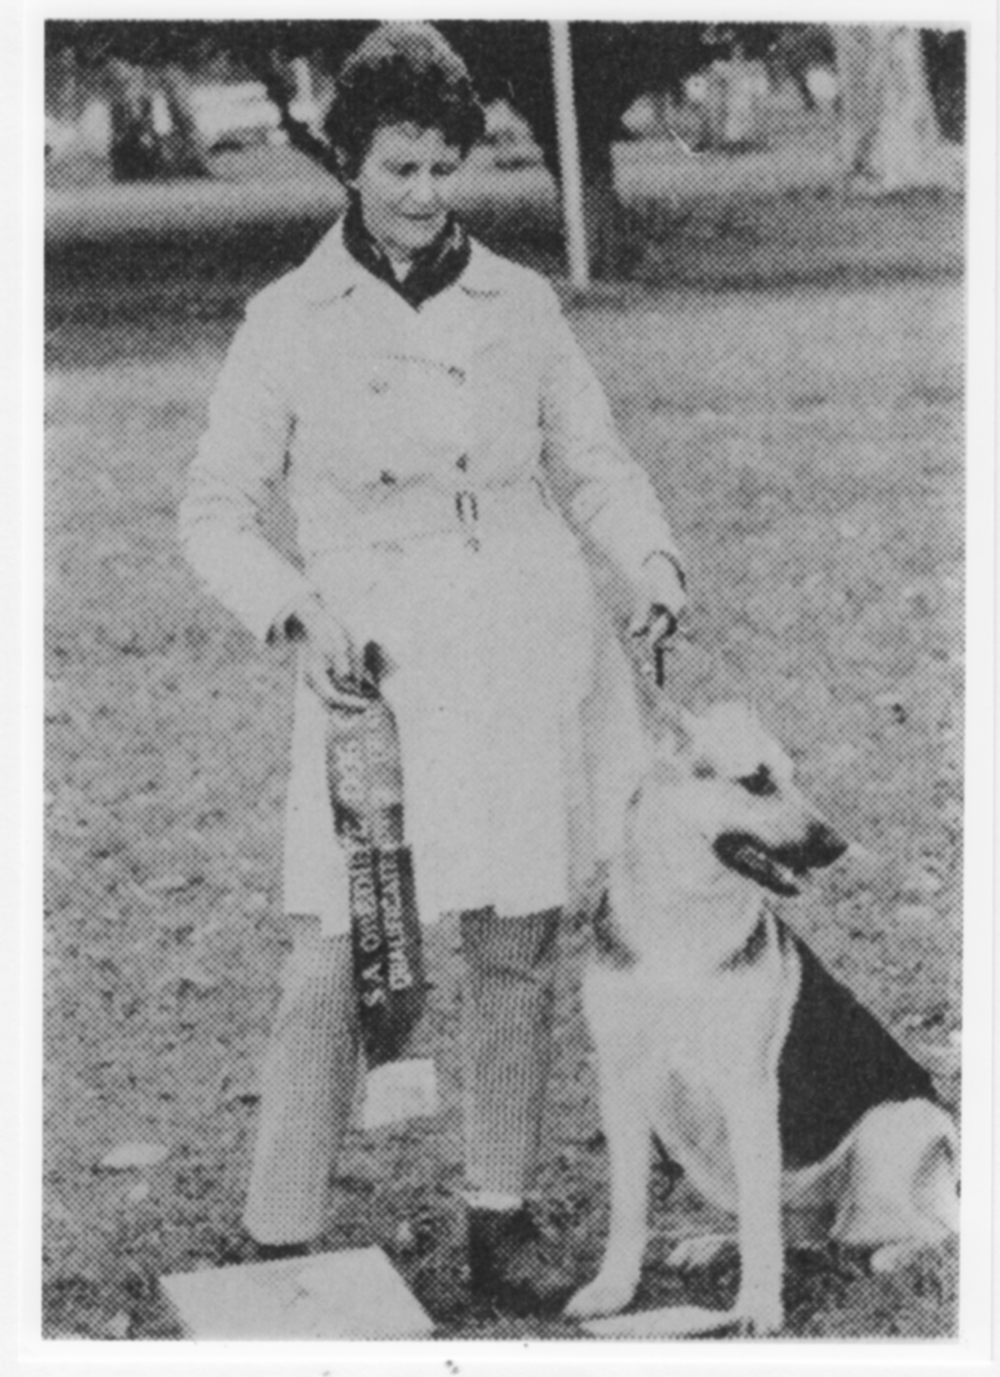
Club Founder Betty McMonagle with her second dog Glen Bonnie Lady Alicia in July 1970 having won the Novice Bitch class at an SAODC trial with 197 points
The Dover Gardens Club has always been involved in a wide range of activities in addition to Sunday morning training. It became affiliated with the South Australian Canine Association in November 1969 and organised its first Obedience Trial in August the following year. The committee progressed to running two trials a year in 1978, and Dover's May and October trials have been popular events in the Canine Association's calendar ever since.

Many club members and their dogs have excelled in the trial ring. At least one dog a year has attained the Utility Dog title since Rita Hunter and her Corgi 'Pattie' earned the club's first in 1979. Several club members, including Philip Rush and Dave Rumble (Head Instructor 1976-85), have become trial judges and gone on to provide outstanding service to the sport in South Australia.

In 1979 Dover held the first all-breeds Endurance Test in Australia. Eddie Simpson (President 1974-77, 78-79) set the pace on the lead bicycle with his Boxer 'Mighty' running along side. The German Shepherd Dog Club had been organising these fitness tests for their members for nine years. At Dover's request, the Canine Association altered the rules to allow any dog to take part. In 1998 Dover responded to widespread interest in Agility and began training sessions on Thursday nights.

Between 1976 and 1981 the club also lived up to the 'Kennel' component of its name. Eddie and Brenda Simpson were responsible for developing the club's conformation activities, which included classes to teach members how to handle dogs in the show ring, Conformation Parades and Open Shows and, from 1979, an annual Championship Show. However, soon after the Simpsons left the club to concentrate on Eddie's goal of qualifying as an all-breeds conformation judge, the committee decided that the club could not continue to manage shows.

The club has always been active in the wider community as well, promoting responsible dog ownership and the value of canine companionship through training demonstrations at schools, fetes and shopping centres and visits to nursing homes. In 1992 these principles became the foundation of the club's training program when George Biggs (Head Instructor 1989-92, President 1992-96) introduced an eight week Basic course based on the American Kennel Club's Canine Good Citizen program.

The development of the Dover Gardens Club since 1969 is thanks to the efforts of successive committees and the dedication of its many instructors. Most of these people began their association with the club training their dogs on Sunday morning. The future of Dover also lies with the willingness of ordinary members to make their own contribution to the life of the club.

(Originally prepared July 1999)
Sources
Minutes of the Dover Gardens Kennel & Obedience Club
Pooch Patter, newsletter of DGK&OC
South Australian Canine Journal
Tape recorded interview with Betty & Peter McMonagle, 6 June 1999 (OH 535, State Library of S.A.)
Conversations with Dave and Dot Rootes, John and Rosemary Fitzgerald, Eddie and Brenda Simpson, Dave Rumble and current members of DGK&OC.
Note that Jim Richardson died in the mid 1970s. Sadie Richardson returned to Scotland to live.

