Sister Frieda Selma Klotzbücher (1899-1944)
Lutheran Missionary in World War 2

Introduction
Frieda Klotzbücher was one of 333 church missionaries were died during the Japanese occupation of Papua New Guinea in World War 2. The largest number were Roman Catholic (197) but all major denominations suffered losses. Some names are relatively well-known, such as the twelve Anglican ‘New Guinea Martyrs’ whom the Anglican Church in Australia commemorates each year on 2 September. Others such as Frieda Klotzbücher who was among the 17 Lutheran missionaries in the total, are little known. Originally from Poland, she lived in South Australia before becoming a nursing sister at the American Lutheran Mission at Amele near Madang in Papua New Guinea around 1936. She was captured and imprisoned with other missionaries by the Japanese army in December 1942. She was one of 63 killed on 7 February 1944 when American bombers attacked the Japanese ship on which they were being transported.
A chance encounter with her in a photograph in an unconnected family album prompted this research and the recovery of a remarkable story.
From domestic help in Poland to nurse in Australia
Frieda was born in 1899 in Rogowo in the province of Posen, part of Greater Germany that became Poland under the Treaty of Versailles in 1919. Her parents, Emile Klotzbücher and his wife Auguste (nee Koerth) were German like the majority of the population in Posen. Their loyalties in World War 1 would have been with Germany, not the Polish people and their aspirations, and certainly not with the Russian enemy. The actual impact of the war on them is not known.
As a young woman Frieda worked as domestic help in the village of Tiege (now Tuja, Poland), near the Danzig Free City (Gdańsk). She also visited family in Germany in the early 1920s.
In 1924, she and her younger brother Oscar came to Australia no doubt looking for new opportunities and freedom from the ongoing German-Polish tensions. They settled in Jindera near Albury in New South Wales where relatives had lived for decades. Johann Briese had been one of the first farmers in the district having come there in 1866 from Posen via South Australia. Their closest family were their aunt, Amelie Briese and their cousin, (Carl Otto) Waldemar Briese.
Frieda was intent on training as a nurse. In 1927, she was employed at Rokeby Private Hospital in Albury. She moved to South Australia and from early 1930 was employed as the midwifery nurse at the new South Coast District Hospital in Victor Harbor. She then nursed in Mount Gambier in the state’s south east before moving to Adelaide around 1934. She passed the midwifery course at the Queen’s Home in Rose Park and then worked at the Infectious Diseases Hospital at Northfield.
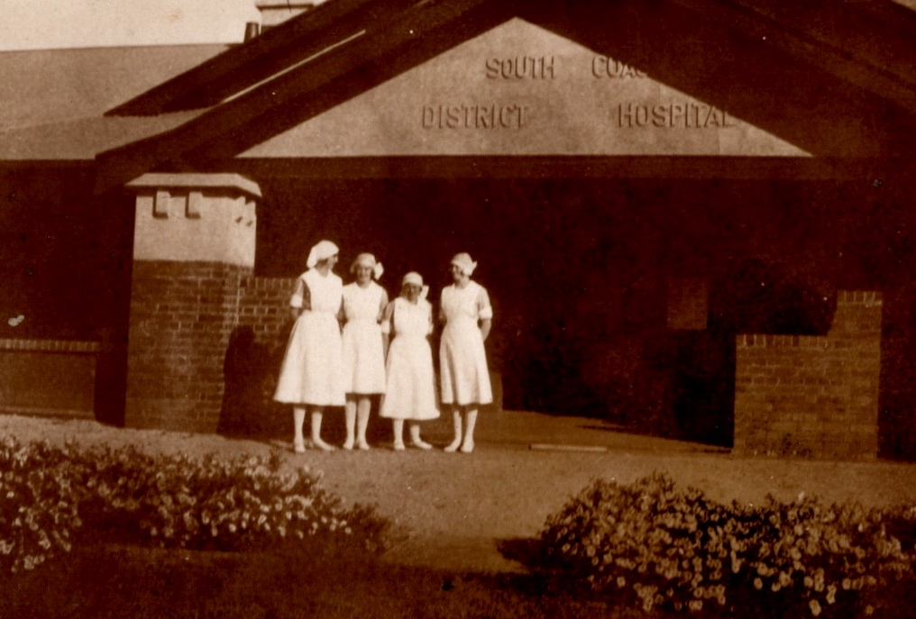
Frieda Klotzbücher (second from right), South Coast District Hospital, 1930.
Jean Campbell coll, author’s possession

In 1934, Frieda applied to be naturalized. She stated that while she intended to live permanently in Australia, ‘she may wish to take a position in New Guinea, as a nurse.’ She was well-equipped to do so with experience in general nursing, midwifery and infectious diseases. She was Lutheran, very likely a worshipper at St Stephen’s Church in the city whose minister vouched for her good character in the naturalization application. Around 1936 she joined the American Lutheran mission near Madang on the north coast of New Guinea.
The Lutheran Mission at Amele
The Lutheran Mission Madang was financed and staffed by the American Lutheran Church, with assistance from the United Evangelical Lutheran Church in Australia (UECLA). The main site was in Madang, with a smaller more isolated centre at Amele15 kilometres inland. The Amele mission included a small hospital led by American Dr Agnes Hoeger where indigenous people were treated for a range of tropical diseases including malaria, parasites and ulcers and pneumonia. The hospital had three nurses, Klotzbücher from Australia and two Americans.
Japanese Occupation
In the aftermath of the Japanese invasion of New Guinea in early 1942, the real and perceived loyalties of the Lutheran mission staff, particularly those at Finschafen which was directed from Germany following the Japanese invasion in early 1942 were questioned. That issue and the reaction of Australian authorities have been studied by historian Hank Nelson. The lives of many Finschafen missionaries were saved because they were subject to compulsory evacuation and interment.
Klotzbücher was among 28 Madang and Amele mission staff who refused to evacuate after the Japanese occupied Rabaul and Lae. For much of 1942 they continued their work of evangelism, teaching and medical treatment although their stocks of crucial drugs such as quinine became critically. In December 1942, Japanese forces took Madang and soon after the Lutheran missionaries who remained were taken prisoner, along with Roman Catholic priests and nuns from the Alexishafen Catholic Mission.
A few weeks after the invasion the 14 surviving Lutheran missionaries, including Klotzbücher, were brought together with Catholic missionaries and confined on a series of nearby islands. They survived by growing vegetables and fruits and eating fruit bats and snakes but their food supplies diminished, the restrictions grew, their health steadily declined. They were moved to another island as soon as their crops grew. Allied planes strafed and bombed them every day.
Death
Allied attacks intensified in early 1944 and the Japanese authorities decided to transport their troops and prisoners closer to their base in Hollandia 600 kilometres to the northwest. On 5 February, the missionaries – 138 Catholics and 14 Lutherans – and 100 troops were loaded on to a ship, the Yorishime (or Dorish) Maru. The missionaries were placed on deck while the Japanese soldiers guarding them went below. The ship was sighted by American reconnaissance planes and soon after dawn on 6 February, attacked by American bombers off the coast at Wewak. The carnage was terrible. Sixty three missionaries on the deck were killed or died shortly after, 56 of them Roman Catholic and 7 Lutherans. Sister Klotzbücher was killed instantly.
The ship reached Wewak, 10 kilometres away. Sister Klotzbücher and the others who died in the attack were buried on the hillside there. The ship continued to Hollandia with the survivors. They were liberated two months later in April by advancing Allied troops, and believed to be the first white prisoners in the country to be released.
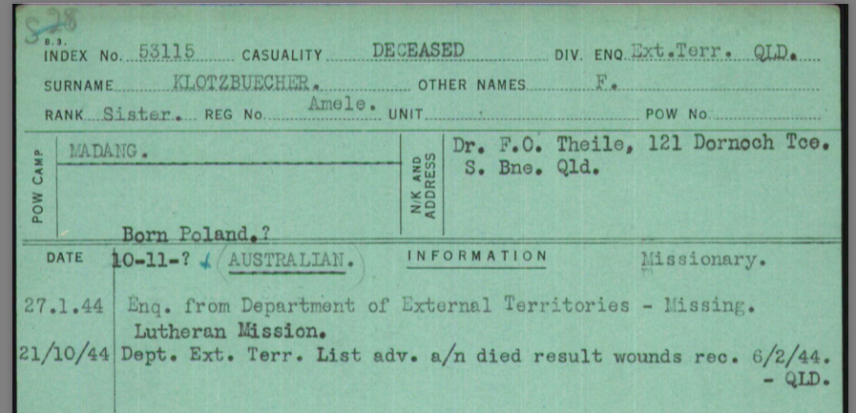
Klotzbücher's Australian Red Cross Missing File (University of Melbourne Archives)

Accounts of their treatment and fate appeared in many newspapers around Australia. Although there was no specific mention of Klotzbücher among those killed, she was not forgotten. One Sunday in August 1946, the Lutherans in Mount Gambier welcomed home 14 men and women from their community who had served in the war. They paused to remember three who had paid the supreme sacrifice. One was Frieda Klotzbücher, who had been a member of their community when she nursed in the town in the early 1930s.
Frieda Klotzbücher had grown up in the Great War in an area which was fought over by Germans, Poles, Russians and the Allies. She sought a new life and a profession in Australia and then New Guinea. Tragically she was caught up again in war and after great privation at the hands of the Japanese army was killed by American forces. She was 45 when she died. Her brother Oscar with whom she had come to Australia in 1924 and who lived in New South Wales died in November 1965 and is buried in North Albury.

Janet Scarfe (janet.scarfe@internode.on.net)
24 May 2020
Janet Scarfe is a professional historian and independent researcher. Her current research interests include women in WW1 and WW2 and family history. The photograph of Frieda Klotzbücher came from the collection of the author’s aunt, Jean Campbell, who was on the staff with Frieda at the South Coast District Hospital, Victor Harbor in 1930.

Lutheran Church, nurses, Mount Gambier, World War 2, missionary

Most information about her life before she became a missionary is taken from documents in the National Archives of Australia, an official declaration she made in 1927 (NAA D4880 German/Klotzbücher F S) and her application for naturalization in 1934 (NAA A1 1935/1656).
http://www.gang-gang.net/briesegenealogy/histories/ludwigbriese.php?sitever=standard
For the Lutheran Missions in Papua New Guinea, the impact of the Great War 1914-18 and particularly the Pacific War of 1942-45, see H. N. Nelson, Loyalties at Sword-point: The Lutheran Missionaries in Wartime New Guinea, Australian Journal of Politics and History, Vol 24 (2), 1978, pp199-217. Nelson’s main focus was the mission and missionaries at Finschafen, 275 kilometres south east of Madang, which was run by the Neuendettelsau Mission Society based in Germany.
West Australian, 10 August 1938, p5; Cairns Post, 17 September 1938, p6.
Nelson, Loyalties at Sword-point, p212.
Nelson, Loyalties at Sword-point, p212.
Theo Aertz (ed.), The Martyrs of Papua New Guinea: 333 Missionary Lives Lost During World War II, University of Papua New Guinea, 1994. The chapter on the Lutheran missionaries was written Gerhard O Reitz. See also Nelson, Loyalties at Sword-point, p212.
Hollandia, once in the Dutch East Indies, is now in the Indonesian province of Papua.
Father John Schrauder, Catholic priest on the ship, wrote a graphic account of the attack in his diary. See https://www.dorishmarucollege.org.au/about-us/death-on-the-dorish-maru . His focus was the Roman Catholic missionaries.
Border Watch, 22 August 1946, p13.

