Grace Montgomery Howard/Farrell: founding wife, mother and grandmother of Trinity

Leith MacGillivray

Grace Montgomery Neville, born 8th May 1812, probably in Ireland, was a founding wife and mother of South Australia. Because of her marriages to the first two colonial chaplains, Charles Beaumont Howard and James Farrell, she was also a founding member of Trinity Church, with which she was continuously associated for 34 years.
Sadly, because none of Grace’s personal records is extant – at least in Australia – we have no documented evidence, from her perspective, about her origins, her personal faith, or her participation in Trinity Church, and must draw on second-hand opinions. This makes interpretations of Grace’s life and character, at best, conjectural.
Grace Neville began her life’s work as a clergyman’s wife when, at 20, she married Charles Beaumont Howard, M.A., a graduate of Trinity College, Dublin, and self-declared evangelical whose avowed purpose was ‘to preach Christ and Him crucified’.
During the Howards’ early ministry in England two daughters were born – Grace Montgomery (2 December 1833) and Barbara Isabella Mary, or ‘Bel’ (27 January 1835). Following Howard’s appointment as Colonial Chaplain, the little family, together with Grace’s sister, Rachel, and servants Margaret Shines and Catherine Kenny, sailed in the Buffalo to the unknown colony of South Australia.
Howard shared a love of dancing with fellow Irishmen. His violin playing to accompany the dancing on board ship drew both favourable and unfavourable comments, as did his sermons. However, Rosina Ferguson, Scottish immigrant, admired neither Howard nor his wife. She declared that, although Howard was ‘too given to the pleasures and politics of the world, his gun, or a dance’, he might improve, but his ‘very vain, gay wife was a drawback to him’. However, Rosina Ferguson was comparing Howard with the beloved pastor she so sadly missed, and her Scottish piety might also have coloured her view of the Howards. Governor Hindmarsh also observed that Grace was a ‘handsome’ but ‘insinuating, tale-bearing woman’, but the inarticulate, bluff sea-captain may well have been no match for Grace’s ready wit. Nevertheless, this was not the last time that Grace's words were to provoke criticism or offence.
While in the early stages of another pregnancy, Grace was to endure her first Australian summer in a tent on the sandhills of Holdfast Bay. By June the family had moved to their first home – a six-roomed Manning house, erected by Howard, on the church town acre on North Terrace. While her dedicated husband pastored his scattered flock on foot, Grace cared for her family, paid the social dues and attended the church functions required of a Chaplain's wife, as well as nurturing a small Sunday School.
On 15 October 1837 their weakly little son was born. Baptised ‘Charles Neville’ by his father when three days old, the baby died and was buried by his father the following day. Yet public duty came befºre private sorrow. Grace and her husband grieved apart as Howard, Colonial Chaplain, took his place with other public officials to celebrate the news that Princess Victoria had become Queen.
In July 1838, at the christening ceremony of Emily Anne Fisher, daughter of Elizabeth and James Hurtle Fisher, the Resident Commissioner and members of Trinity, Grace wore ‘stiff corded black silk’. Known as one ‘very fond of dress and showing it off’, did Grace wish to stand out in black among other parishioners, all of whom wore pastel colours? Or was she still in mourning for her son? If the latter, perhaps her sorrow may have helped her to comfort her servant, Catherine Kenny, now Catherine Monck, wife of John Monck, Trinity Clerk and West Terrace Cemetery sexton, who was to lose her five children in infancy.
When the evangelical Governor, George Gawler, and his wife Maria, arrived in September 1838, they found the Howards ‘in weak bodily health’ because of their ‘largely unassisted labours’, but with the former’s patronage and encouragement, a District Visiting Society was formed and the Sunday school began to flourish. William Ross, an experienced London teacher, was Superintendent of the Sunday school and Head of the Native School Establishment. The boys from the School, in their bright red shirts, and the girls in their long, grey dresses and white headbands regularly attended Trinity Sunday School. Among these was Kudnarto, tutored in European ways and, perhaps even by Grace, in the Christian faith, who, when she married Thomas Adams, was the first aboriginal woman to marry a white man.
In 1848 the current Governor, Sir Richard MacDonnell, another Irishman with Trinity College connections, visited the impressive Sunday school. It was, conceivably, partly because of Grace’s work and influence in this area, that he named the mid-north township of Grace and Grace Plains after her, a rare honour for a woman.
By 1840 the Howards had two more daughters – Henrietta Hindmarsh (9 February 1839) and Elizabeth Susannah (27January 1840), known affectionately as ‘Henni’ and ‘Muttie’ respectively. Grace was possibly more an ‘evangelical widow’ than previously, as Howard, now on his horse, Luther, visited burgeoning congregations further afield at Port Adelaide (St Paul’s), Angaston (St Peter’s) and Gawler. We know, however, that Grace accompanied him on at least one occasion in 1842 when he preached to over 30 people in the barn of friends Bessie and Frank Davison, at Blakiston, near Mt Barker.
With a Church of England membership in the colony of 12,000 by 1840, Howard had the assistance of 36 year old bachelor, James Farrell, M.A., fellow graduate of Trinity College, former curate in England and Ireland, and incumbent, since September, at St John’s in the Wilderness (now Halifax Street). Farrell shared the burden of parish work and the increasing financial stress of establishing a church in the colony’s first economic depression. Already in weakened health from these strains and a severe cold, Howard caught a chill in the bleak, wet July of 1843 when he went beyond the bounds of duty, doubtless mindful of his own little son’s death, to bury the infant son of John Bull. He died on 19 July 1843, entrusting Grace and his children to his friend and colleague, James Farrell.
At 32, Grace was now a widow with four young children, and as Howard had died intestate, was left with a dower and a few lots of heavily-mortgaged land. She moved to Octagon Cottage in East Terrace, the home of Osmond Gilles, Colonial Secretary and Trinity trustee, which home Gilles gave as the parsonage for St John’s. Here another catastrophe befell Grace. In November 1844 a fire broke out and she lost furniture and family possessions. Despite contemporary propriety, Grace may have returned temporarily to Trinity parsonage, where Farrell had been living as second Colonial Chaplain since Howard’s death, especially if accommodation for a woman and four children were not forthcoming, but within two months she was residing, possibly holidaying, at Glenelg.
In February 1845, a scandal broke in Adelaide. James Farrell faced prosecution for indecent assault, brought against him by Richard Charlesworth, shoemaker, on behalf of his 14-year-old daughter, Sarah, Grace’s servant of only a few days. The Adelaide press covered the trial fully. Despite stifling heat, Adelaideians packed the courthouse, while bystanders peered through windows, to witness the prosecution of the chaplain of their foremost church.
The trial revealed that Grace, her sister Rachel, four children, Sarah and Farrell had crammed into the four-roomed Glenelg cottage, with Farrell sleeping on the sofa in the parlour, opening onto Grace’s bedroom. From here one morning, by her own admission during the trial, Grace impatiently called twice to Farrell to wake Sarah. Entering Sarah's room in his nightshirt, on his second attempt Farrell shook her, pulled back the bedclothes and, according to Sarah, ‘touched her on her left breast’.
During the trial, James Hurtle Fisher sat beside Farrell. Fisher, known as a ‘wily academic lawyer’, was not only counsel for Farrell, but had also been an original trustee and influential member of Farrell’s church. Further supported by several prominent citizens who rallied around a member of their class, Farrell was finally acquitted because of insufficient evidence, but the case had laid bare the distinct social and economic advantages Far- rell had over a 14-year-old servant girl. He left the courtroom ‘much affected’. His indiscretion was to set serious consequences in train.
Governor Grey informed Downing Street and the Right Rev. Dr. W. G. Broughton, Bishop of Australia. Both agreed that Farrell was ‘guilty of breaches of propriety and decorum’ expected of ‘a minister of the gospel’. Although Farrell was appointed Dean in 1849, Broughton declared he ‘lacked the qualifications for any superior ecclesiastical office’, let alone ‘the Head of the Establishment of the Church of England in the province of South Australia.’
A little over two years after her husband’s death, but having known Farrell for five years, Grace and he were married quietly on 12 November 1845. For want of a Church of England clergyman to officiate, the marriage was performed by the Rev. Robert Haining in the little stringy-bark Church of Scotland, St Mary’s-on-the-Sturt. The news took ten days to reach Adelaide’s press.
The Farrells had embarked on a marriage in which Grace proved neither a stoic nor a pliant wife. Her daughter, Grace, noted several domest^{i}c conflicts ^{i}n her diary, and almost a decade after her mother’s marriage, was still commenting, ‘What a sad thing these family disputes are.’
Almost a decade after her own marriage, Grace Farrell saw her eldest daughter married. In 1854, 21-year-old Grace Howard was confiding to her diary, not only her annoyance at persistent overtures from one suitor, but her increasing pleasure in the company of Charles Marryat, 27-year-old Oxford graduate, incumbent at St John’s since April 1853, and socially well-connected as Bishop Short’s nephew and brother of Lady Augusta Young, wife of the current Governor. Grace’s growing admiration for Charles had to survive one serious setback, however. Her spirited defence of her Irish fondness for dancing drew strong criticism from Charles. Later, when he preached ‘against the vanities of this world’ from 1 John 5:14, Grace was quite sure ‘he was directing his words partly at her’.
However, with a reconciliation achieved, on 8 August 1854 Grace Howard and Charles Marryat were married at Trinity, with her step-father, James Farrell, officiating. If Grace Farrell had an qualms about losing her first child in marriage, her unease would surely have been allayed had she known of Charles’ prayer to his diary: ‘O God, bless this marriage of mine to my temporal and spiritual and ministerial good ... In seeking my own happiness, I have not forgotten Thy glory.’
Ten months later Grace Farrell became a grandmother for the first time, when Charles Howard Marryat, or ‘Charlie’, was born. In years to come Grace was to be grandmother to eight more Marryat children, six of whom survived her, but none seemed to give so much delight as this first grandson, perhaps because he reminded her of her only little son, Charles, who had lived for just five days.
A shadow had fallen over the Marryats’ wedding however. Muttie had been too ill to be bridesmaid and was to die two years later, at only 16, from one of her ‘usual attacks’, and was buried beside her father, Charles Howard. Heartbroken at the loss of a second child, Grace seemed to take comfort ‘only from her grandson, Charlie, and the sight of his merry little face.’
In November 1857, Grace became the mother of two brides dressed exactly alike, when Bel married John Williams, pastoralist of Black Rock station, and Henni became the wife of Captain Morley Saunders of the 12th Regiment. The assertion of Douglas Pike, historian, that Grace wished to see her daughters ‘married well’ may have seemed a reality with Bel now married into landed wealth and society, and Henni the wife of an army Captain with a promising career, but both marriages were threaded with sorrow.
John Williams was consumptive, frail even at marriage. Yet it was ‘the much-loved Bell ... of the sweet disposition’ who was to die first, nine years after marriage, and leaving no children. Grace Farrell had now to mourn the loss of a third child. Likewise Henni, with an itinerant husband posted at various places within Australia and as far afield as India, had to bear much responsibility for her children’s upbringing. Her sister, Grace Marryat, found the children unruly and ‘sadly spoilt’, while grandmother Grace found them very difficult to handle on their infrequent visits. More serious was Morley's ‘queer behaviour’, about which Grace Marryat was so concerned that she spoke with her step-father, and both consulted the family doctor. Furthermore, in Sydney in 1863, Saunders faced a prolonged court-martial ‘induced by his Colonel’s conduct towards his wife’. Saunders had first taken leave from his base without permission, after which consequent charges were preferred. With the reporting of the case in Adelaide, Grace Farrell and family endured the unwanted publicity of a second scandal until Saunders’ acquittal a year later.
By the 1860s the Farrells were ‘empty-nesters’ at a time when both the colony and Trinity church had consolidated following a post-mineral buoyant economy. Indeed, Trinity was now considered the society church of Adelaide and ‘no society people ... would have any other clergyman to marry them while [Dean Farrell] lived’.
The Farrells, with their own and their son-in-law Charles Marryat’s connections, now moved in circles which included a judge, politicians, governors, and men of high commerce. One admirer, a friend of the Howard children since governess days, and a member of society herself, described hostess Grace as ‘tall, handsome, and exceedingly clever’, as never wanting in social poise, knowing always ‘how to do a gracious act’. This knowledge, her friend added, came ‘from breeding’, which lends some credence to Grace’s reputed descent from the Neville Earls of Warwick. Yet Grace’s often mordant wit and mimicry had not mellowed with time. Many found that her ‘irresistible temptation’ to ‘take the fun out of anyone’s peculiarities kept them in fits of laughter’, at the same time as it understandably made many enemies.
Perhaps mindful of his earlier indiscreet behaviour, as well as the expectations of – and obligations to – his parishioners, Farrell tempered his interests accordingly. Although passionately fond of horses, he did not attend race meetings – but always rode in that direction. He loved whist – but never played for money. Yet two features of Farrell’s life remained above reproach. Firstly, as Grace Marryat’s diary attests, the Howard children had ‘truly found a second father’. Further proof of his caring responsibility lies in the ornate memorial plaque in Trinity, erected by Farrell, in memory of the ‘esteem and affection’ he had for his other two step-daughters, Bel and Muttie. Secondly, in his preaching of the gospel, he remained as staunch an evangelical as his predecessor – ‘no eloquence, no oratory, but a solemn, simple manner in the pulpit, that carried conviction to all’.
Within a few years the Farrells faced declining health. The Dean had become progressively more ill, very possibly from swallowing an embrocation containing lead and potassium in mistake for his usual medicine. Early in 1868 he paid young Charles Marryat’s fees for St Peters College and gave him a Bible. Grace’s gift to Charlie was his cap and gown. By August Farrell was so ill he had not been able to preach for three months. In November he journeyed to England, seeking the currently popular water cure, but died on 26 April 1869. As the Observer reported, ‘The veteran evangelist sleeps far from the scene of his labours’. Now twice widowed, Grace, ‘completely prostrated with grief ... would not put on her weeds for some time.’
From a variety of judicious investments, Farrell died a very rich man. He left his wealth not to Trinity, not even to his wife, save for a £200 annuity, but to St Peter’s College, the school for ‘young Christian gentlemen’ with which he had had a long association and involvement. Embarrassed at such munificence, the College Council resolved to appoint Grace as Lady Visitor, with a salary of £200 per year.
As well as coping with bereavement, Grace was ailing from the effects of often vomiting blood, persistent bronchitis and a serious fall. Grace Marryat was with her when she died from ‘a disease of the heart’ on 18 July 1870 at Christ Church parsonage, spared the knowledge that Henni was to die in Ireland six years later, leaving eight children, the oldest of whom was twelve, and a husband committed to a lunatic asylum in 1883.
Grace had survived her two husbands, three of her five children and two grandchildren, both of whom were also named Grace. She is buried in West Terrace Cemetery with her first husband, her children Bel and Muttie, and two grandchildren. On the simple headstone are roughly etched the letters ‘GMM’ and ‘HHS’ – those of her two daughters, Grace Montgomery Marryat and Henrietta Hindmarsh Saunders, buried elsewhere.
Because Grace cannot speak for herself, we can draw only inconclusive assumptions about her. Some disliked her for what they saw as vanity, social climbing, imperious manner and hurtful tongue. Others saw a different side. They enjoyed her wit and sociability, saw her vulnerable in loneliness and grief, and resilient to private criticism and public scandal. Within her marriages and church fellowship she knew first-hand that forgiveness and salvation come through grace alone. If she spoke to herself as forthrightly as she did to others, Grace would surely have known she stood in need of grace as much as any.
She has two memorials. At St Peter’s Cathedral a stained glass triptych, which forms the Resurrection window depicting the women at Jesus’ tomb, was dedicated to the first Dean of Adelaide, James Farrell and his wife. It was moved to Trinity in 1912 when the cathedral was extended. Also now in Trinity a memorial tablet to Grace is flanked by similar tablets commemorating her husbands. Both of these memorials are in the chancel. The words on Grace’s tablet encourage Trinity members to remember the good that Charles Howard, James Farrell and she did, and to hold all in affection.
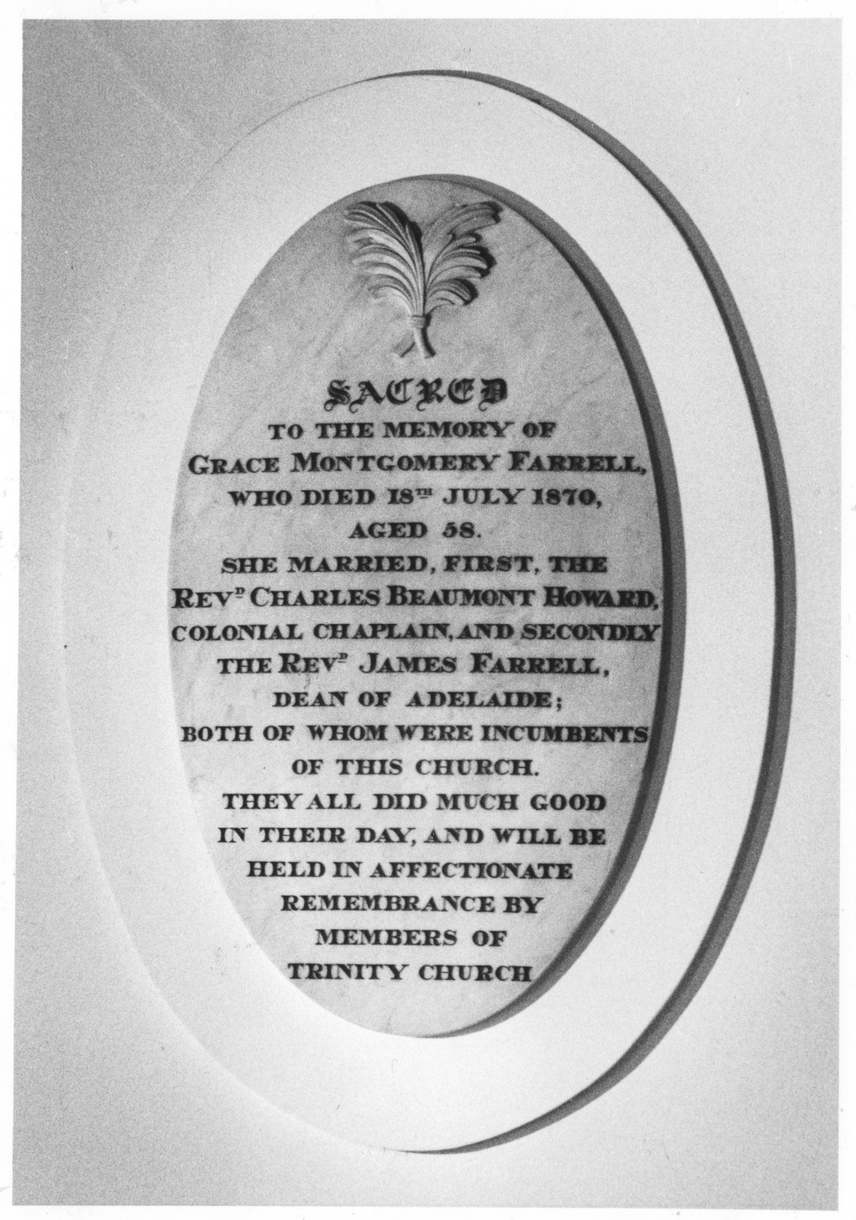

One might add that the words speak also of many other early 19th century founding Trinity women, about whom we know even less than we do about Grace Montgomery Howard/Farrell.

