An Australian cash cow? The legalisation of poker machines in South Australia
Susan Marsden

The battle lines are drawn and the guns are beginning to fire as several States start again on legalising poker machines. Over the years I have seen more of these battles than most – not just in Australia but elsewhere in the world and they are very predictable. In Australia, things usually start off with the clubs’ associations wanting poker machines. Their reasons are obvious. They see the success of clubs in New South Wales and are frustrated by the attitude of their State Government who seem to legalise all other forms of gaming but throw their hands up in horror at the suggestion of poker machines.
Once they announce their intentions the opposition starts … [but we] in New South Wales … are not dehumanised; we are not criminals; we are not individuals who cannot stop ourselves from pouring our pay packets into poker machines.
I can only conclude … that the anti-forces have no arguments against machines at all except grossly distorted facts, brimstone and fire.
We went through it all in Canberra and we will go through it all again and again.

They would indeed – and when Sydney-based poker machine manufacturer Len Ainsworth made these comments in Aristocrat News in 1979 he was embarking upon an ambitious, expensive, and controversial campaign to win the war over legalisation outside his home state of New South Wales (NSW). Leonard (Len) Ainsworth, the ‘patriarch of the pokies’, is universally regarded as the father of Australia’s poker machine industry. ‘Playing the pokies’ is a typically working class pastime, but Ainsworth’s story was that of an entrepreneurial middle class man who helped build that pursuit into an addictive and (for machine makers, purchasers and tax agencies) lucrative form of mass entertainment, and a global industry.

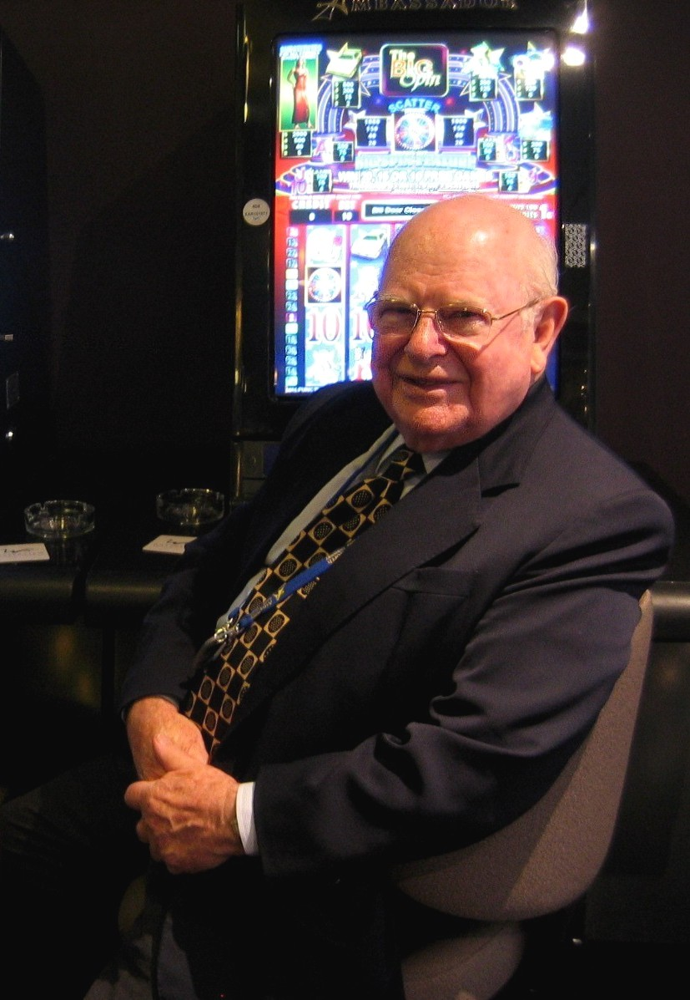
Len Ainsworth and an Aristocrat poker machine, 2006 (Photo: Susan Marsden)

The history of gambling machines is colourful, controversial and complicated. Gambling – placing a wager or bet on the outcome of a future uncertain event – is as old as human society, and as widespread. Betting tools always adopted the technology of the time, whether roughly carved pieces of bone, printed playing cards, or computerised poker machines. In the late 19th century, when American business led the world in mechanisation, the development of gambling machines and a means to manufacture them, was inevitable. A century later, those machines were computer systems with video screens and sound systems, built and marketed by global manufacturers with huge research and development budgets. Ainsworth’s company Aristocrat was one of them.

The poker machine business later called Aristocrat was launched in Sydney in 1953 when Ainsworth began repairing and making poker machines at the dental supplies factory established by his father. Poker machine playing was illegal in NSW, as elsewhere in Australia, but state authorities turned a blind eye to their use in social clubs, and there was an escalating demand. Australians had imported ‘slot machines’ soon after their invention in the USA in the 1890s, but later legislation restricting casino gambling in the US to the state of Nevada had wiped out many American slot machine manufacturers. As a recent history notes, ‘The Australian market, already undersupplied, then represented a potentially vast market – indeed, that country was soon to become the world's second largest slot machine market, trailing only the United States’.

Soon after Ainsworth joined the industry, the local market expanded further when the NSW state Parliament legalised poker machines in registered clubs in 1956. Aristocrat became the main Australian manufacturer, outselling, buying up, and forcing other competitors from the industry. The company’s success was due in large part to designing innovative machines and providing good customer service. Aristocrat introduced many successful new poker machines, and was quick to realise the potential of electronics and other technologies. By the mid-1960s Aristocrat was the dominant manufacturer in Australia and had become a significant export industry, flying Australian machines to British and American casinos. Customers in the 1980s also included China, Turkey and Germany. During the 1990s Aristocrat’s video poker machines became major competitors with American manufacturers in the US, at the same time as dominating new Australian markets.

In 1979 when Ainsworth wrote his comments in Aristocrat News the licensed club associations of Victoria, Queensland and South Australia wrote asking him and other manufacturers for help in persuading their governments of the benefits of legalising poker machines. An Australian Club Development Association was set up at a meeting with the three state associations in June 1979. Ainsworth paid $150,000 a year to the lobby group to have poker machines legalised in those states, paid an additional $100,000 a year to an agent to run the campaign, and made direct donations to political parties.

In Queensland the opposition Labor Party planned to conduct a survey into the benefits of introducing poker machines, accusing Joe Bjelke-Petersen’s conservative government of hypocrisy in opposing them but not other forms of gambling. Rupert Hamer, another conservative premier who opposed poker machines, was facing an election, giving clubs in Victoria the opportunity to present their case to both government and opposition members. Ainsworth Distributors’ group general manager Peter Clareborough declared, ‘We have simply made ourselves available to those parties who wish to get accurate information about the likely effect of the legalisation of machines in their State’.

Ainsworth’s efforts were plainly business-driven. Having seen off local competitors Aristocrat was facing a wave of overseas poker machine suppliers entering an expanding Australian market, and was also faced with tightening regulation. Poker machine regulation as well as revenue became part of the formal apparatus of government, in NSW, and progressively in other parts of Australia. By the mid-1990s, as Ainsworth observed, governments had discovered ‘a cash cow in gambling’. Other Australian governments said ‘were all saying, ‘Tut, tut, tut, tut, those gambling people in New South Wales, how terrible. But when they needed money badly enough they were very quick to follow’.

Unlike in NSW, casinos were the first legal gaming centres permitted in other states – although not, at first, their use of poker machines. The first wave of casino legislation had boosted marginal economies in Tasmania and the Northern Territory by attracting tourists and raising revenue, and additional casinos were opened in their second-largest towns in 1982. A new wave of legislation introduced casinos into three more states. Queensland’s Casino Control Act 1982 allowed for legal hotel-casino complexes, and in 1985 Conrad Jupiters Casino was opened on the Gold Coast. Burswood Island Casino in Western Australia, and South Australia’s Adelaide Casino also opened in 1985. Another opened in Queensland at Townsville, in 1986. Canberra Casino opened in 1992, and Christmas Island Casino opened in another Australian territory in 1993 ‘with 100% Aristocrat Machines’.

Aristocrat profited when Queensland became the first jurisdiction beyond NSW to legalise gaming machines in both clubs and hotels following the Gaming Machines Act of 1991. South Australia, Victoria, Tasmania and the Northern Territory also introduced electronic gaming machines (EGMs) during the 1990s, but Western Australia still does not permit them in hotels or clubs.

Premiers in South Australia and Victoria held fast against poker machines until the early 1990s when both State Banks, having over-extended, veered towards collapse, leaving huge public debts. Labor governments in both states were replaced as a result. Their successors supported gaming as a source of much-needed revenue, and (with a nod to years of lobbying) to improve the financial viability of clubs and hotels. South Australia’s Gaming Machines Act legalising machines in hotels and casinos was passed by one vote in 1992. The Treasurer anticipated that poker machines would generate $143.5 million in tax revenue by 1996/7.

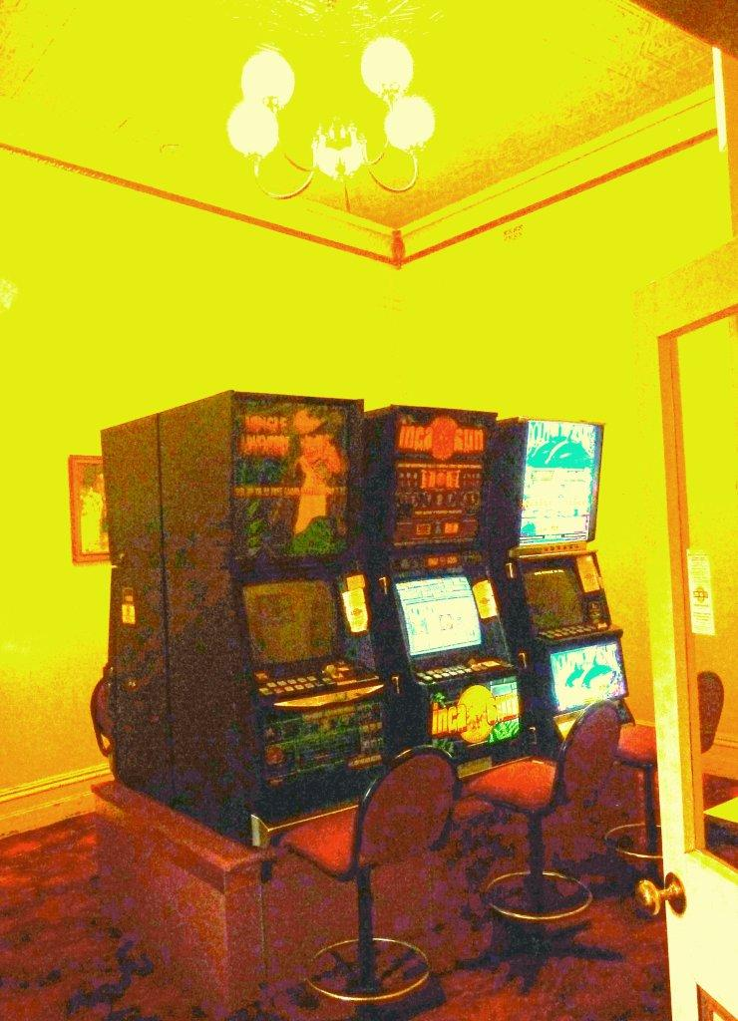
Pokies room at a country pub in South Australia, 2010 (photo: Susan Marsden)

Aristocrat soon controlled the South Australian market, but not without criticism. In 1994, as the first EGMs were being installed, Deputy Premier Stephen Baker told Parliament there were major supply problems. He said, ‘Aristocrat – which was delivering some of the worst machinery that we have received in the State and which has been actively soliciting business in South Australia – has secured a major share of the market but has failed to supply machines for scheduled installations’.

All the same, both Aristocrat and Ainsworth’s new company AGT enjoyed a massive growth in electronic gaming machines (EGMs) and venues from this time. In 1995/6 Aristocrat recorded sales of around $260 million with 25,000 machine sales locally and overseas. The Sydney Morning Herald reported ‘Behind the most recent jump in sales is the gambling boom throughout Australia which lifted turnover to more than $5 billion last year.’ AGT followed Aristocrat in gaining access to the Queensland market when this was granted in 2002 and in South Australia in 2003. AGT installed Ambassador poker machines in that state in the same year.

Total expenditure on gambling in Australia rose from $1,104 million in 1977-78 to $15,365 million in 2002-03, an average annual growth rate of 5.5 per cent. Australia’s population growth and rising household incomes contributed to greater numbers of gamblers, but, even taking that into account, gambling consumed an ever-increasing proportion of household budgets. In the 25 years after 1978, expenditure per adult and share of household disposable income more than doubled.

Venues with gaming machines in Australia by State/Territory 2001-02
State | Clubs | Hotels | Casinos | Total
New South Wales | 1,388 | 1,828 | 1 | 3,217
Victoria | 293 | 251 | 1 | 545
Queensland | 610 | 748 | 4 | 1,362
South Australia | 87 | 505 | 1 | 593
Western Australia | 0 | 0 | 1 | 1
Tasmania | 12 | 94 | 2 | 108
Australian Capital Territory | 69 | 6 | 0 | 75
Northern Territory | 36 | 29 | 2 | 67
Total | 2,495 | 3,461 | 12 | 5,968

Both in Australia and in the US – for similar revenue-related reasons, and promoted by the same American and Australian manufacturers – legal casino-style gambling expanded dramatically during the 1980s and 1990s. As the use of legal gaming machines spread to all states, except Western Australia, and Australia reached one twentieth of the world’s machines gambling became a big business, with ‘governments looking for revenue and private industry looking for a share of the market’.

The changing pattern of gaming was not simply a matter of growth as poker machines were legalised. In 2001 national and state ministers in Australia agreed on the ‘dramatic increase in problem gambling that followed the expansion of electronic gaming machines in the 1980s and 1990s [and that]…there was a lag of at least several years in most jurisdictions between the emergence of significant levels of problem gambling and the development of coherent and independent regulatory structures’. A national response began to emerge through the Ministerial Council on Gambling, and the response of Community and Disability Services Ministers.

A recent exhibition mounted by South Australia’s Migration Museum, conveys the deeply mixed views held in Australia about this modern gaming industry. The display included games illustrating gambling’s long history, and the varied forms brought by British, Asian and other migrants to Australia. At the same time the exhibition drew attention to the negative impact of ‘gaming’.

Efforts by government and church organisations to control or suppress gambling were of equally early date in Australia as the activity itself, and as continuous. When local government was established in Britain’s former penal colony of Sydney in 1842, the middle class aimed to establish control over the city’s moral as well as physical environment. By-laws were enacted to regulate ‘disorderly houses’, gaming tables and gambling. Official tolerance of the most popular forms of gambling hardened into broader, more formal controls or bans. Between 1876 and 1897, all six of the Australian colonies (later, states) enacted legislation prohibiting gaming activities, such as lotteries and gambling machines. Gambling policy in Australia remained the responsibility of the states rather than the Commonwealth, until late in the following century.

The Migration Museum exhibition placed most emphasis on the impact of contemporary gambling. Gaming has become big business – and, while not mentioned in the exhibition, Aristocrat is one of the biggest. Commercial gaming has changed gambling into an industry, which has introduced a wider range of gambling activities to a greater number of people, and has transformed club and hotel industries wherever it has been legalised in Australia. Almost as many women as men now gamble on poker machines. The exhibition curator wrote, ‘In South Australia commercial gambling is supported and regulated by the State government, however, there is ongoing tension about where social gambling stops and problem gambling begins.’ An exhibition visitor wrote: ‘Unfortunately gambling provides entertainment and hope for those who are not lucky enough to be born into privilege…’, and another visitor noted, ‘Gambling is the art of moving money from those who need it, to those who don’t.’

State and territory jurisdictions legalised machine gaming for similar budgetary reasons, but adopted different taxation approaches. Although Ainsworth strongly promoted legalisation of poker machines, and benefited from expansion of the market, he argued repeatedly that other states made a mistake in not emulating the NSW system. He said that other governments came up with ‘their own idea of regulations and, with the exception of Queensland where it was done quite well, in Victoria they’ve made a dreadful mess of it and they’ve made a dreadful mess of it in South Australia’. Their mistake (he said) was to provide machines to hotels on the same terms as non-profit clubs. ‘If they’d differentiated the way they should have in my view, then they wouldn’t have had any of these upsets they’ve had and they could have had just as much money in their bin’. In South Australia the state government, despite evidence of the social dangers of this approach, was persuaded to this course by the front bar vote, and by the lobbying of the hotel industry.

Compelling, but contradictory displays in the Migration Museum exhibition illustrated the attractions of poker machine playing, on the one hand, and research on the social and economic impact, with a graph showing that poker machine gambling is a more serious problem than earlier forms of ‘problem gambling’. As an exhibition visitor wrote, ‘Gambling is all kinds of things. Problem gambling is mostly about poker machines.’ But this in itself is a reflection of the success of the gaming industry, and the extent of its popularity, in South Australia, as elsewhere. Other visitors pointed out that ‘pokies make money for the pubs which pay wages’, and described their own enjoyment of gambling, as part of everyday life. One person wrote, if some people ‘can’t handle it, don’t deny others the rite 2 gamble’. ‘Gambling only becomes a problem when you CAN’T AFFORD IT.’

This essay draws together excerpts from the manuscript history by Susan Marsden, Len Ainsworth: Patriarch of the Pokies (Sydney, 2008).
Len Ainsworth, writing in Aristocrat News vol 1, no 4, Feb/Mar 1979, pp 1-2, held in Ainsworth’s archives (AA).
Answers.com, Aristocrat Leisure Limited, viewed June 2007 <www.answers.com/topic/aristocrat-leisure-limited?cat=biz-fin>.
See also Powerhouse Museum, NSW, Poker machine, ‘Queen of the Nile’, 1997, viewed Nov 2006 <www.powerhousemuseum.com/collection/database/?irn=358514&search=poker&images=&c=&s=>
Ainsworth left Aristocrat in 1994, and it became a public company in 1996. In 1995 Ainsworth founded a new poker machine company in Sydney, Ainsworth Game Technology (AGT). In the period Ainsworth Nominees controlled Aristocrat, from 1953 to 1994/5, a total of 193,678 poker machines were produced, with a further 215,000 produced or rebuilt in England and the US, that is over 400,000 machines in 40 years. (AA, Box 43, Licensing AGT: Application by AGT for grant of a poker machine licence, Licensing Court of NSW, Holden, Sydney, 17 Aug 1998, Decision, p 3).
AA, files held on Australian Club Development Association; Age 13 Sept 1983.
AA, Aristocrat News vol 1, no 4, Feb/Mar 1979, p 1.
Interview with Len Ainsworth by Susan Marsden and Paul Ainsworth, recorded in Sydney, 18 April 2006 (transcript, p 30).
Tasmania - the first state to legalise casinos, did not legalise gaming machines in clubs and hotels until after the other states, in 1997.
See also CM Hall & C Hamon, ‘Casinos and urban redevelopment in Australia’, Journal of Travel Research Winter 1996, viewed Nov 2007 <http://jtr.sagepub.com/cgi/content/abstract/34/3/30>.
Inquiry into Australia’s Gambling Industries: Submission by John Ridley, c1998, viewed <www.pc.gov.au/inquiry/gambling/subs/sub045.pdf>.
SA Parliament, House of Assembly (Hansard), SJ Baker: Gaming machines, 4 Aug 1994.
Sydney Morning Herald 14 Feb 1996.
Australian Financial Review 30 Apr 2003.
SA Centre for Economic Studies, Report: 3.1 Recent history of Australia’s gambling industries.
SA Centre for Economic Studies, Report: Table, p 38.
Queensland Government, Gambling in Queensland: History viewed Dec 2006 <www.responsiblegambling.qld.gov.au/education-services/school-stuff/schoolstuff/text/txt_history.html>.
Community Services Ministers’ Advisory Council Submission to the Review of the Commonwealth Interactive Gambling ACT, 2001.
History Trust of South Australia, Migration Museum, Three sides of the coin: gambling in South Australia, Exhibition, Aug 2006 (notes taken by S Marsden).
S Fitzgerald, Sydney 1842-1992, Hale & Iremonger, Sydney, 1992, p 40.
For the Commonwealth’s increasing role, particularly with electronic gambling, see summary in K Jackson, Gambling Policy and Regulation, Parliament of Australia Library, Sept 2001 <www.aph.gov.au/library/intguide/SP/gambling_ebrief.htm>.
Migration Museum exhibition, Three sides of the coin, 2006.
Post–it note visitor’s comment, on display at Migration Museum exhibition, 2006.
Australasian Gaming Machine Manufacturers Association, Observations Paper submitted to Productivity Commission Inquiry into Australia’s gambling industries, 1998, viewed April 2007 <www.pc.gov.au/inquiry/gambling/subs/sub050.pdf>.
Interview with Len Ainsworth, 18 April 2006 (transcript, pp 19-20).

