Trinity Church Adelaide and the Covid crisis 2020

Brian Dickey

A version of this essay first appeared in Lucas: An Evangelical History Review, Series 2, no. 16, December 2020, pp.123-148.

I have been writing about the history of Trinity Church Adelaide since the 1980s. In two books, three substantial articles and some lesser pieces I have been exploring the story of this evangelical Anglican church set in a largely high church diocese. There have been highs and lows since the church’s foundation in 1836. Since 2000 it has been the centre of a highly successful process of establishing new church congregations in Adelaide and the surrounding region.
The strength and continuity of this church planting project, and of TCA itself, was gravely challenged by the outbreak of a virulent new strain of respiratory disease, labelled by the World Health Organisation, ‘Covid 19’ in January 2020, followed by the necessary community responses which were imposed by state and federal governments under the wide-ranging powers authorised by the relevant Biosecurity Acts available to them. How would TCA respond? Would it cope? Would its governance bear the strain? Would its members stay the course? What would TCA look like at the other end of the crisis? These are the questions this essay will address. As will become apparent, there are also important issues about the nature of church leadership and about how crisis management can be conducted effectively running through this narrative. I will return to these questions in my concluding remarks. I am well aware that a wide variety of churches in Australia, and in many other parts of the world, moved to present their services online. It must also be recognised that South Australia endured a much shorter period of total lockdown than some other Australian jurisdictions. Notwithstanding these qualifications, this essay is a case study exploring the various questions I have posed, using as its focus a complex and highly developed church, one that is part of a network that on the one hand, possesses substantial resources, and on the other, enjoys relative freedom within the diocese. As I will show, the outcome has been an impressive, flexible and largely successful response to this modern crisis.
Before 2020 the closest Trinity Church came to closing on Sundays, and thus denying the possibility of public worship, was in the midst of the Spanish flu pandemic which raged through the world and in Australia 1919-1921. On 16 June 1919, Frederick Webb, the fourth incumbent at Trinity Church Adelaide, wrote in the remarks column of his Vestry Record Book for that Sunday, ‘cars, trains not running’: It was a practical community lockdown in the face of a frightening and widespread pandemic that was killing millions of people across the world. Yet, despite the epidemic and such public restrictions such as the widespread wearing of face masks, services were held as usual at Trinity Church, as they were in other churches in Adelaide without any break in the regular sequence.
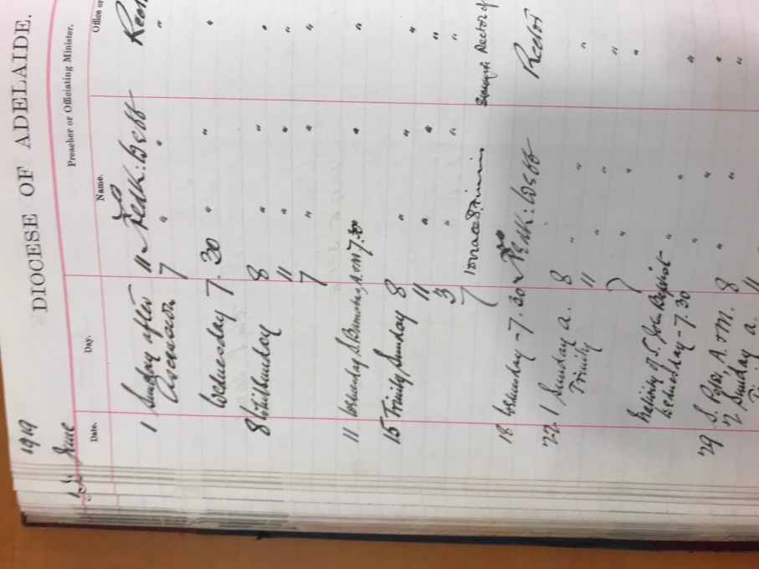

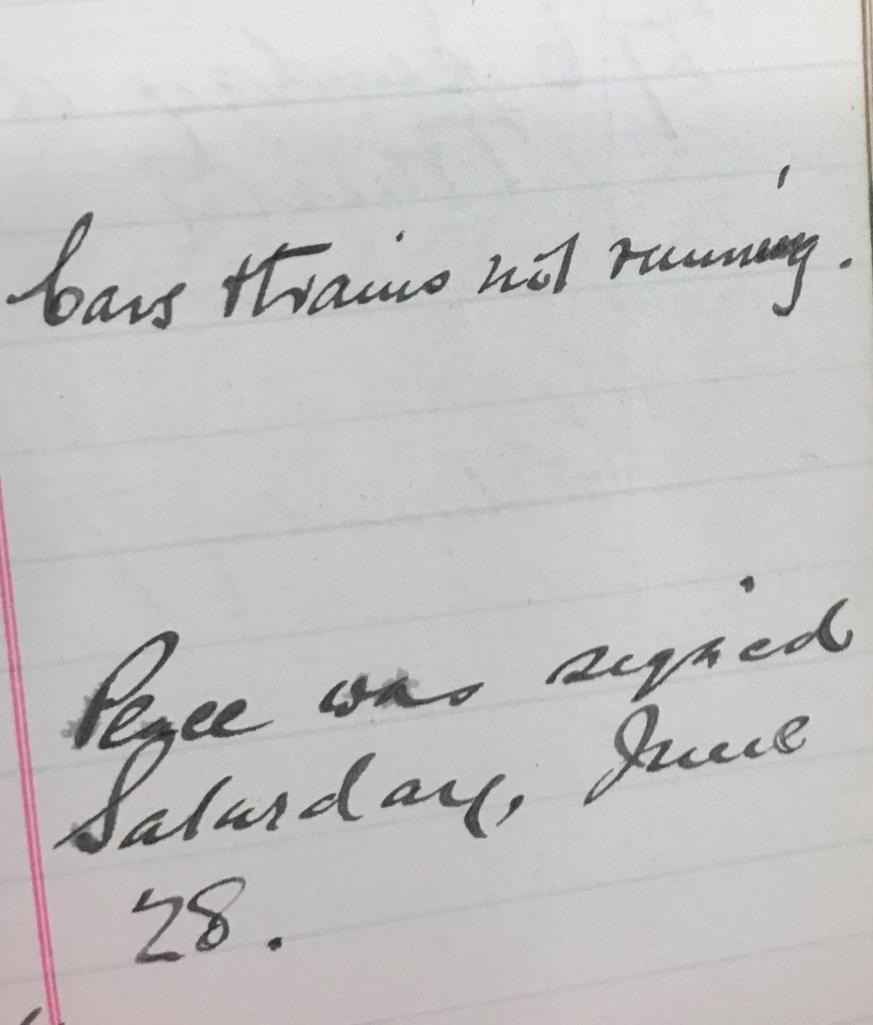
Trinity Church Adelaide, Vestry Record Book, State Library of SA, SRG94/A2/19, vol 2.
A century later, at the time of another pandemic, the situation facing the Trinity Church was different. On Wednesday 18 March 2020, the Prime Minister of Australia, supported by the state premiers, announced nation-wide lockdown measures which effectively included the immediate cessation of all church services. There would be no public worship in Trinity Church on North Terrace the following Sunday, 22 March. This was new territory for the Christian churches of Australia. There were no precedents to guide them. The Covid crisis had struck and it posed serious challenges for them.
Trinity Church, a parish of the diocese of Adelaide, is governed by a trust deed of 1836 rather than the diocesan parish ordinance. There are three trustees, since the 1970s operating as an incorporated body. Their most significant role is to appoint the incumbent of the church on North Terrace, who is then presented to the bishop for licensing. As I have shown elsewhere, this has seen the growth of a church organization probably unmatched anywhere else in Australia. Thus TCA is now also part of the Trinity Network of Churches (TNC) which contains TCA and ten other congregations, spread around Adelaide, the Hills, and to the south coast at Victor Harbor. TNC is a company established by the Trinity Trust Incorporated, with a board of directors operating under the Companies Act. The current rector of Trinity Adelaide is the Revd Paul Harrington, who is also CEO of the Trinity Network. He appoints his key staff, the senior pastors of the eleven congregations making up TNC, and they in turn appoint their teams. With no elected parish council, it is a top-down leadership model. The senior pastor (currently the Revd Des Smith) convenes an advisory leadership council drawn from the five congregations comprising the membership of TCA. The church’s current vision statement is: ‘By God’s grace, for God’s glory, making, maturing and multiplying disciples of Christ.’ To fulfil this vision, the pastoral staff are largely tasked by function, employing a widely adopted church management tool, the ‘Five Ms’: Ministry, Magnification, Membership, Maturity, Mission. The meaning of these categories will become apparent as this essay unfolds, as I have used them to organize of the narrative. As is apparent, this church is highly unusual in its leadership structure, but as we shall see, these arrangements became an important factor in the quick, disciplined and successful response to the challenges posed by the Covid crisis.

In order to maintain proper historical perspective, it is important to keep in mind that the life of TCA has continually evolved. Public worship has continued unbroken since the time of CB Howard, the first incumbent. Using the forms laid down by the Book of Common Prayer (BCP), successive clergymen have led public worship Sunday by Sunday, and on the prescribed holy days, reading and teaching from the texts of Scripture laid down in the lectionary. More recently, the format and pattern of the services has become less formal, and the BCP has been put away. For decades at Trinity copies of the sermons have been distributed, in print, on tape and on discs. These have been replaced by online sound recordings and, since 2016, by video recordings, all available on the TCA website. According to Ben Chapman, Church Planting Director for the Trinity Network of Churches, for some time thought has been given to going the next step, by recording and providing online the whole of at least one Sunday service, or to produce its equivalent in a studio-type production on behalf of the whole network. The Covid crisis precipitated matters already under consideration.
The story begins in December 2019. The obvious source of intelligence, which the leaders at TCA and their people shared with everyone else, was the onward march of reporting in the media about this new version of SARS occurring in a province of China and its main city of Wuhan through January and into February. The first reported case of Covid 19 in Australia was on 25 January. Travel from China to Australia was banned on 1 February. But Boon Yong Sim, pastor of the Mandarin-speaking congregation, one of the five Sunday congregations at TCA, began hearing concerns from his members in December about an outbreak in Wuhan. This gathering contained people who had strong links with China. Many customarily visited family during the January Chinese New Year celebrations, so important for Chinese families. Most were in close touch with friends and relations in China. They were well informed and plainly, watching events closely. Boon Yong told me:
We heard about this [new infection] towards the end of last year. [There was] news from China about a virus coming out of meat wholesale place. The subsequent shutdown of the city of Wuhan (which has few million people) further caught our attention. Initially, we thought it was a local breakout and that the Chinese authorities would be able to deal with it efficiently. In Singapore [where Boon Yong had previously ministered] we had been through SARS in 2003. So when it became clear that the virus that has caused the respiratory conditions [that was being talked about in Wuhan] were of the same kind as SARS, we were worried. A few weeks prior to the shutdown of gatherings at TCA, at the Mandarin gathering, we started to introduce hand sanitiser, and provide surgical masks. We did not keep social distancing, nor did we adopt spraying down after the gathering, although a few members of our gathering suggested we do this. They had heard from family and friends in China, that this was carried out there in order to minimise spreading.
Duncan Ward, the property manager, was assisting Boon Yong Sim in the drive for good sanitation. Not only that, but in early February he had commenced precautionary cleaning of pews and doorhandles throughout the site, similar to what was done in the height of the annual influenza season. ‘This involved a good wash of all the pews in the church, while MOOD was still running.’ By mid-February he started researching WHO information on Covid to understand what was needed. His previous experience as a project engineer was standing him in good stead. Like everybody else, he and the rest of the Trinity leadership were handicapped by a lack of government information on how to prepare. The emphasis in government announcements was still on persons returning from hotspot countries, especially China. But Ward was fielding requests from the staff for the supply of hand gel at events to back up the already deployed bottles at church entrances, well before the Covid issue arose.
Paul Harrington began to pay attention to the chatter about Covid: ‘there started to be talk about churches closing … we have contacts in the medical world. For example Ben Chapman via his medico wife, said that the talk in the medical world was that closedowns were coming.’ By contrast, quite reasonably the diocese of Adelaide had no advice to offer at that stage about was likely to happen, because like everyone else, they were flying blind and waiting for clear directions from governments, both state and federal. So Harrington and his executive team started planning: ‘probably two weeks before the official lockdown, [that is around the beginning of March], we had the whisper.’
Ben Chapman and James Agnew, the communications manager for the network and for TCA, started to think carefully about the implications of this highly infectious virus. If the church was closed, could they build on Chapman’s concept of developing an online opportunity for people in the network to worship? Could this provide an alternative in the light of the approximate attendance rate of two-thirds among TCN members? Could this expand TCN’s footprint well beyond the places where church is currently conducted on Sundays? Helpfully, Sarah Chapman was keeping her husband posted on developments. Sensing that the ability to meet publicly on Sundays would soon be at risk, in February Chapman commissioned James Agnew to research electronic solutions to the problem of holding a church service. Agnew later told me that because Ben Chapman had been tracking the Covid story closely, he was predicting church shutdowns by the beginning of March. With time in hand, they sought an online platform that would meet the Network’s needs. They quickly realised that live streaming lacked flexibility and demanded too many people in production to make it happen. So it would be pre-recording. After a quick look at Facebook and YouTube, Agnew turned to other platforms. He discovered the Church Online platform, which seemed to be the ideal system. It included all the features he wanted, including the ability for people to chat on the platform, to have hosts who could interact with viewers, to link people to the website pages, and to schedule church online to run at specific times. They then considered one online service as a Network, versus each church creating its own church online service. Because it was important for the members of each church to maintain a close connection with their own church, and for pastors to be able to care for their own congregations, they opted for each church in the network being enabled to deliver its own service. These were well-based predictions yielding flexible, prompt responses. They bought TCA time and, as later events have shown, enabled its leaders to adopt effective solutions.
Meanwhile, Boon Yong also passed on his concerns to Des Smith, TCA’s senior pastor. Smith recalled:
Boon Yong alerted me to it, because he was hearing stories and concern being raised, from those with family in China or who had returned to China for Chinese New Year to be with family. He encouraged me to start putting out basic info about when to attend or not; so we were putting out spot emails fortnightly about when not to come aimed mainly at the Mandarin congregation, eg ‘if you have been to Wuhan don’t come [to church]’. We thought that would do, and it was still a Chinese focus.
During March, matters began to move more rapidly. First, there was detailed staff planning, then direct action by the leadership, both of the Trinity Network and Trinity Church Adelaide. On Friday 12 March, Ben Chapman met with Des Smith, Matt Lehmann (senior pastor at Trinity Church Colonel Gardens), and Stephen George (senior pastor at Trinity Church Modbury) for two hours to war game what might need to happen if services shut down. Chapman introduced ‘Church Online’ to this group, showing them how it might work. Smith then spent Saturday doing more planning.

Monday 16 March was busy and momentous. In the morning Smith led his TCA team through a detailed discussion of how, on the following Sunday 22 March, they might administer Holy Communion safely. They scrabbled over the details of safe practice and decorum, only to find very quickly that their time among the minutiae had been wasted. After lunch Paul Harrington contacted all the senior pastors from the Trinity Network, seeking a consistent decision on whether it would be possible to hold church services that next Sunday. The consensus was clear that it was too risky. Harrington then consulted the Network Board, who accepted his recommendation and authorised the closure of all Trinity Network churches forthwith. For the first time in the history of Trinity Church Adelaide, there would be no public worship in the historic North Terrace building, or at any of the other TCN venues. Nor would the sacraments of the church be available. The challenge over the next few days was to craft a viable alternative.

Immediately, Paul Harrington drafted a formal announcement that was principled and, despite the news of closure, designed to be encouraging. This went to every member of the Trinity Network churches on Wednesday 18 March. He began by reminding everyone that ‘we have a loving and Sovereign Heavenly Father’, that members should pray for mercy upon the community and for the health professionals involved in particular. He urged everyone to consider how they might behave lovingly to those around them, despite the limitations being imposed. He justified the closure on public health grounds, explaining that the gathering limits imposed by the state government could best be met in the Trinity Network by an immediate, voluntary cessation of public worship. He promised a replacement through online services. He urged small groups meetings should continue, subject to government rules, and that everyone should adopt a heightened concern for one another. Later that same day Des Smith followed up with a similar circular to TCA members. He offered each congregation ‘Church Online’ at their accustomed times by logging onto the TCA website. He urged everyone to continue their other Trinity-linked activities as normal, subject to whatever government regulations that might be issued.

The practical implementation of these promises lay ahead. James Agnew ‘worked late into the night every day that week to set up Church Online platforms for each church in the network, edit their church service videos (each church took responsibility for filming their video content), run church online tests for staff to learn the platform, update church websites, etc.’

At North Terrace, Michael Morrow, the Magnification pastor, was the key coordinator and producer. His duties included planning the conduct of Sunday services, selecting music, coordinating and rehearsing performers, and all the associated rosters. He also regularly shared in preaching. When, in early March, Duncan Ward walked into his office, and said ‘now I need to talk to you about if we can’t continue gathering for church’, Morrow laughed. He hadn’t even considered it. He didn’t believe it. He thought it was way over the top. Despite his initial scepticism of Agnew’s choice of platform, when he first saw how it worked, including such features as the chat component which permitted online interactive conversations in a side bar to the main video, he was convinced. But it meant that he and his helpers spent a lot of time working out how to use it in that first week. Morrow brought professional skills in audio recording: after he completed his music degree, he did an audio course then worked for two years as an audio producer with a TV studio producing advertisements. He was familiar with the audio side, and also the necessary procedures, though not the visual side. He has also written and recorded a large number of songs for private and public worship, accompanying himself on piano or guitar. He has his own website promoting these works.

So, guided by James Agnew in that first furious week, Morrow’s team recorded a sermon, prayers, Bible readings, songs, and continuity material.

The first few weeks we were trying to figure out what we wanted to make: we wanted a difference between church and the on line product, so at first we used the crèche room to record, thinking creatively about designing the space. We quickly realised it was better to record in church to get a better look. We filmed for three weeks [as a team], then the Board decided that there should not be volunteers because they feared the pressure this would place on people’s careers. We also had people coming in to be filmed, eg reading, praying. After that I was pretty much on my own. I had to work out how to use the church camera and more …
But soon, the ‘we’ shifted to Michael Morrow alone, when the Board assessed that attendance of volunteers at a workplace contravened the state government’s Covid regulations, so they directed that no volunteers be allowed. He shifted to recording sound with his phone and video with his SLR camera. But he knew this was inadequate. It took a month to research what camera he wanted the church to buy, that would possess high visual quality, and be useful in the long term, for example for videos for use in church services etc. To it he added a Bluetooth receiver attached to the camera for the audio transmissions that fed audio generated from lapel microphones in with the video stream being recorded by the camera. At the same time he responded to an immediate visual problem apparent in Des Smith’s first recorded sermon. He had sat on a couch in a church meeting room dressed up as a ‘studio’, preaching on Luke. But as he could only hold his sermon notes below the camera’s sight line, he engaged in what the army called the ‘emu bob’: his head went up and down for every phrase or sentence. This was deeply distracting, nor did the sterility of the ‘studio’ work at all well. So for the next week Morrow moved recording to the church. He contrived a somewhat ‘Heath Robinson’ teleprompter which involved his ipad mounted on a music stand and sustained by a wooden frame crafted for the purpose. The sermon text appeared, caught by a two way mirror/glass held in a simple frame at 45 degrees, through which the camera could look directly at the speaker, hooded by a black cloth, seated on its own tripod (also new). He soon found that borrowing studio lights was too cumbersome, and so he bought new strong studio lights. Controlling the pace of the ipad text of the sermons to match the preacher’s pace required some nifty stretching and reaching, made easier when he was loaned a Bluetooth keypad.
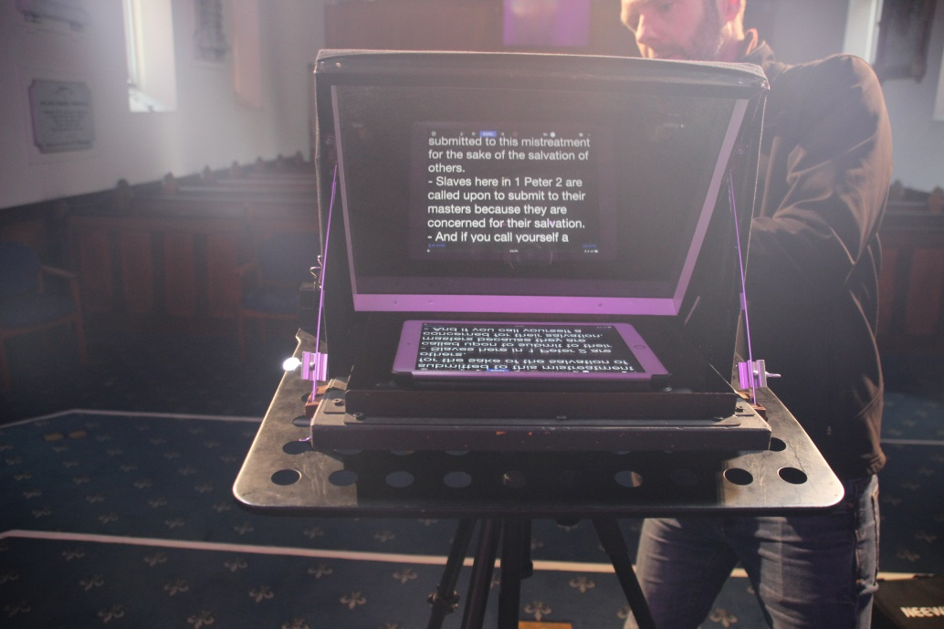
Michael Morrow’s solution for providing a teleprompter. (Image by Brian Dickey}

Despite Smith’s furious rush in the first week, he and successive preachers rarely needed to redo their sermons. Michael Morrow remarked: ‘Those guys are so good. They have to sit in the high chair waiting while we figure out all the technical stuff. They are incredibly patient. Sometimes things go wrong eg the battery in the camera died, instantly, so we had had to redo the whole sermon.’ There was a spectacularly loud ambulance siren the day I observed proceedings, but for the most part these externals were ignored.

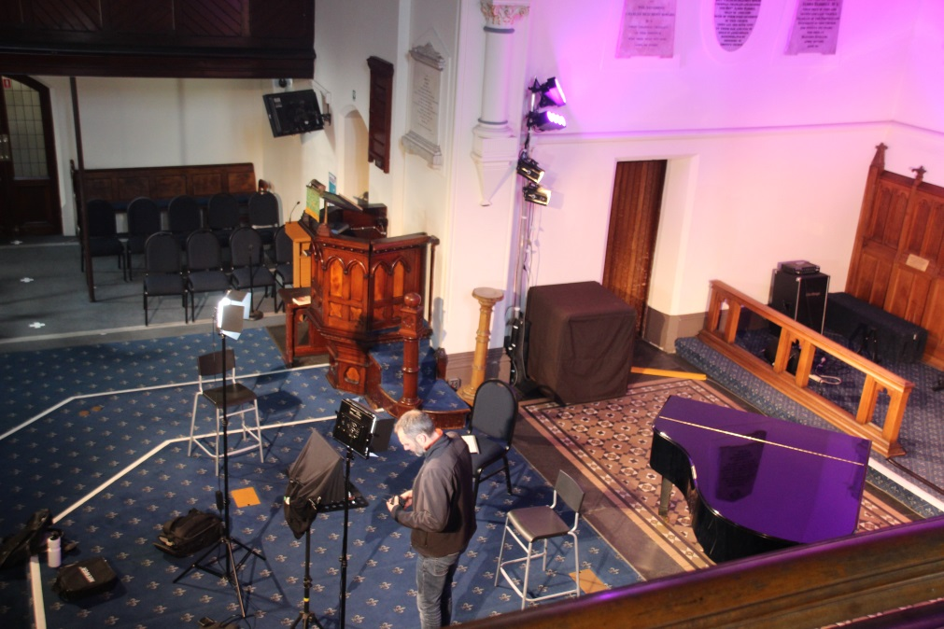

The church as a TV studio, with Michael Morrow preparing the equipment, the teleprompter in front of him, the speaker’s stool behind him. (IMage by Brian Dickey).

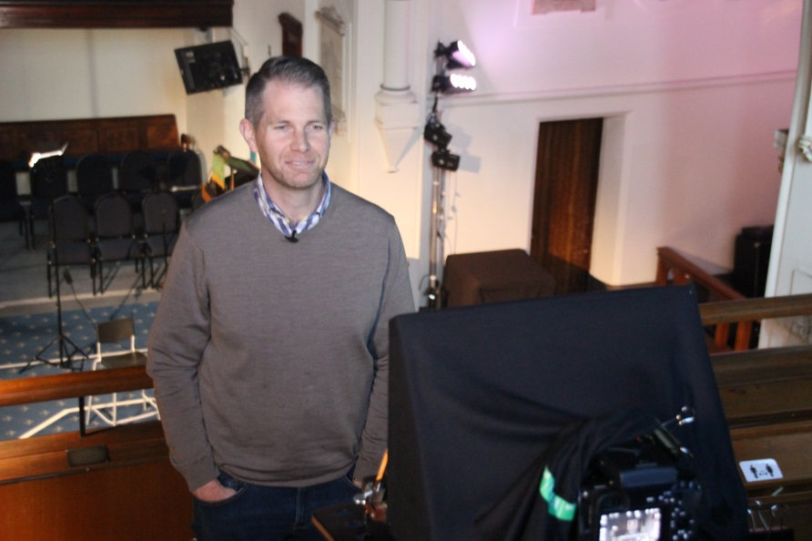

Des Smith recording continuity material while in the western gallery. (Image by Brian Dickey)

Health restrictions usually meant getting people to record themselves at home praying or reading, mainly using their phones. They were learning the technology as they went along (I know I was!). Sometimes it was a struggle.
Because it was done in advance, there was lots of pressure to do things right. On Sundays we just accept what is said, and perhaps have a word afterwards. But if it is recorded, there is a need [and opportunity] to correct things over the four days [between Wednesday and Sunday], eg a verse was left out because the print-out being used was faulty. So we do it again.
Then there was the question of music, which also had to be recorded. As music director, composer, author and presenter, Morrow was on home ground. But wait: ‘I’ve never been filmed before, I’ve done just audio for CDs. I had to think about smiling, my appearance: I look miserable, go back and do it again.’ At his home he recorded everything himself, with multiple takes, moving about the rooms for workable angles and lighting. On one occasion Michael, his wife Julie, and two of their daughters sang together. He wanted something more domestic for home viewing, whatever the number of the singers. Gradually he built a collection of recordings, to meet the varied needs of the four English-speaking congregations.
When it came to the sacraments, Holy Communion was celebrated online, with the leader inviting his viewers to eat and drink their self-prepared elements at home in conjunction with him as he proceeded through the relevant paragraphs of the service. Baptism was plainly not feasible under the Covid regulations. Smith decided, consonant with established practice, to maintain the roster of planned sermon series through the following months. Neither he, nor his colleagues, offered any special theological reflections in their sermons, although the theme of giving was covered in a set of three sermons, while suffering was front and centre in the five sermons on 1Peter delivered mid-winter.
So then, the shift of Trinity’s Sunday services online, offering them at the five normal times, was a major success. Public worship at Trinity Church Adelaide continued without a break.

But there were other pressing matters which needed immediate attention that week. Bernie Leo, the Membership pastor, had responsibility for organising pastoral care. He called on his colleagues to address the issue of those who would be disadvantaged by this shift to on line services. He was very aware of the difficulties posed by the cessation of the monthly Friendship Service. In this gathering, people from aged care facilities or living at home with illness and mobility issues, were brought to North Terrace for a communion service followed by lunch and lots of fellowship. Using a spreadsheet he had commenced the previous week, he listed people in the highest priority of need of support. He included not only those just mentioned, but also those whose jobs were at risk, and front-line workers health workers, teachers and others. He invited staff members to elect whom they were best placed to call. He then allotted the remainder to ensure everyone was contacted. Those active in groups, on the other hand, could be left alone. This process went on over the following weeks to include delivery of the online services to those without such links. Emails, CDs, DVDs, transcripts of the sermon, and even letters were all used by the pastoral care teams. The 9am congregation’s pastoral care team had been in place for some years, and the plan to match it for the other congregations had been under consideration for a while. Covid made this step essential. People were invited, coordinators identified, basic training provided and they set to work with a will.

Bernie Leo also attended to welcoming new members to Trinity. This he normally did by offering four meetings with talks, discussion and a meal, covering such matters as Trinity’s core gaols and values, what church meant, what expectations would be placed on new members and so on. Since he had just prepared some videos covering this material, Leo deployed these online for the flow of enquiring Christians to watch. These were people who identified themselves through the Church Online response forms. He followed this with an email of discussion questions and then Zoom meetings. When, in mid-July, regulations permitted 20 people to meet, the first were these new members, convened on site on Sundays to watch the service on a screen (a ‘watch party’). They were hosted by staff and others. In due course Leo asked them to commit to Trinity’s goals and officially become members, joining a congregation and an appropriate small group, committing to a service team and starting to contribute funds, which they have done willingly.

Thankfully, there were only two deaths at TCA during the first months of 2020, neither linked to the pandemic. Those funerals were private. There were 6 funerals to the end of 2020 and a subsequent 3 in 2021. Numbers for each of these were restricted, varying from 10-200 people able to attend. There is currently (March 2021) a limit of 200. Neither at Trinity, nor in South Australia at large, has there been the challenge of dealing with large numbers of bereaved people, as has been the case in Victoria, or, say Great Britain.

But there were couples planning to marry. One couple managed this on the very last possible day, Monday 26 March, after frenzied phone calls to Births, Deaths and Marriages, as well among the staff, culminating in Paul Harrington calling Bernie Leo as he was driving to the park for the six pm wedding (sanctioned by the archbishop). Harrington wanted assurance that all the rules would be followed, that Leo was ready to cope with any media attention, that the park was suitable. Leo assured Harrington all would be well, and reminded him that the bride was already on her way. He sent him a picture of his ‘official’ garb, of suit and black face mask. Surely that was the clincher!

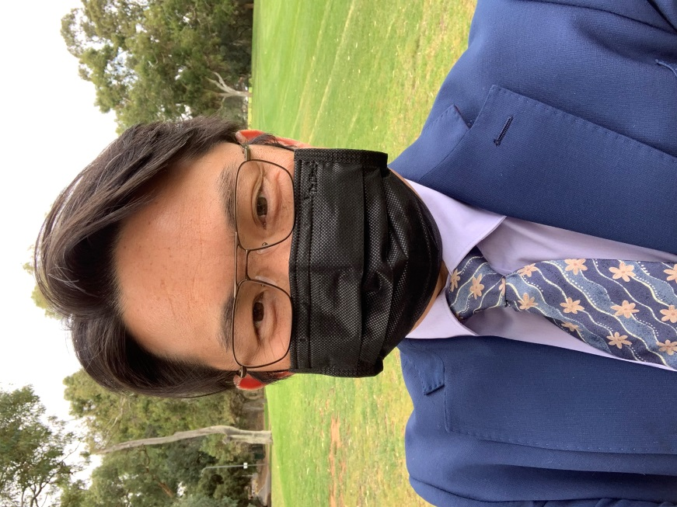

Selfie by Bernie Leo before conducting a wedding in the park

That wedding went ahead, even if interstate guests could not be present. There were five weddings subsequent to the limitations coming into force on 23 March, including one for an international couple, none of whose family could attend. Leo conducted their service in the Delbridge House (formerly the rectory, and now used as office and meeting space). Just the bridal couple, their witnesses and Leo as officiant using the Anglican order of service were present, in accordance with the regulations. The party would have to wait for better times. Generally speaking, weddings have had several different limitations imposed at varying times. At one stage all wedding guests needed to be registered with the SA Health in addition to the required contact tracing. Currently (March 2021) the limit is 200 attendees.

Welcoming people to church on Sundays was stood over during lockdown, but once services on the North Terrace site began again, Leo needed to reactivate his welcoming teams for all services, and brief them on the new and stringent legal requirements about registration, distancing, hand sanitisation, limits for each space on site, distancing rules, traffic flow and so much more. He was quite clear that not only was welcoming now very demanding, but it also carried a health risk, so he offered everyone the opportunity to decline to volunteer if they were concerned.

Overall, Leo, like all the other staff, was impressed by the level of willingness of people to engage, to reach out and offer care to one another in the Trinity family. What had seemed to him a rather top-down model proved one that, in this time of crisis, to draw on deep wells of willing ‘oneanothering’. It is to be hoped that this greater degree of engagement becomes entrenched.

Nor did the people of TCA just ‘church’ on Sundays in large formal gatherings: there were 46 small groups, some nested within larger meetings. These included two women’s groups, Terrace Studies and Thursday Encounter, the Internationals, Young Adults, and Young Workers groups usually meeting on site, and growth groups meeting in homes linked broadly to the five congregations. Simon Marshman, as Maturity pastor, had responsibility for caring for all these ‘growth groups’. He sent a circular to all those on his lists on Tuesday 17 March, encouraging the groups to keep meeting subject to their assessment of risk. All was to be done lovingly and flexibly. He suggested a variety of alternative meeting methods, ranging from simple phone links right through to the then-unknown online carrier, Zoom. But on Monday 23 March, he had to write again, asking them to cease meeting in person and instead move to other forms of interaction and care for one another.

Most responded by adopting this new online resource, and after a few fumbles, groups came back into action. One remarkable example was the large home-based group of mainly over 65s which Bik To and Franklin Bridgewater cared for. Bik did most of the leg work, caring, explaining, visiting and more.

We embarked on getting our group onto Zoom. A step-by- step guide with screen shots was prepared, but only one couple managed to log on. In the end it was multiple phone calls, Facetime calls, one-on-one working together till we managed to get to the first Zoom meeting after two weeks. At the same time we initiated quite a number of members into a WhatsApp group and not a day went by without messaging one another, sharing happenings, verses and stories.

The hard work of getting everyone on line was hugely rewarded even at the first try. The joy on people's faces and in their voices, the sweetness of fellowship and the warmth of connection were overwhelming. People logged on half an hour before the starting time and stayed for an hour after the meeting finished, just to chat and to care. Instead of fortnightly studies, everyone wanted to meet every week so we have to develop a new program for the non-study weeks in a hurry. Not having to get out for meeting on dark wintry nights definitely has its attractions and our Zoom attendance was 80% or above most weeks. We even worked out how to sing hymns individually but together!

For Terrace Studies, it likewise meant that their lead speakers had to record addresses on line for later viewing by the small groups on Zoom, or in one case, in the CB Howard Hall. An interesting pastoral issue was detected by Jack Weeks and Trace Akankunda, the two ministry apprentices Simon Marshman supervised. Weeks overlooked the Young Adults, Akankunda, the Young Workers group. They grasped that isolation, anxiety, boredom and more time on line, were a recipe for disaster for young men struggling with pornography. Marshman constructed a six week course he called ‘Brutal Holiness’ that operated on an ‘invite only’ approach. It offered teaching, discussion, prayer and accountability. It proved to be a great success. Another online gain was that when the group which met monthly to pray for Maggie Crewes, a long term CMS missionary supported by TCA, switched to Zoom, Maggie herself could join in from Cambodia.

Tim Blagg’s work with youth, both at the Network level and at TCA suffered serious reverses. The long-planned network ‘Trinity Youth’ meetings convened only three times before months of cancellation. A TCA youth camp and a mission trip to Roxby Downs, as well as a network Camp, were all cancelled or postponed. It was painful for all involved. There was great relief when Fusion youth meetings reconvened onsite in July, and Trinity Youth in August, and the youth camp could be held in October.

Provisions in lieu of the Sunday children’s programs were even more fraught because Anne Havill, the children’s worker, had concluded her service in December 2019. Simon Marshman, helped by Tim Blagg and Michael Morrow, tried hard to fill the gap.

Within the first week we took kids min[istry] online developing a framework for family discipleship with clear goals of equipping parents to disciple their kids during lockdown. Tim and I worked closely to develop resources that partnered with the Sunday sermons - video component with discussion points and a basic craft activity plus a few suggested songs that related well that people could access online. After a few weeks of scrambling to adjust we then recruited a team of our most keen and capable Prime Time leaders to collaborate on this, and established a medium term schedule that planned out the teaching in keeping with the sermon series, diversified the resources available, and drew on people more gifted in this area than Tim and I. Praise God for a great team and for resources that have been accessed by many more people than we would have normally had on-site for Prime Time (hard to know the exact figures, but basic download stats on the video indicate more families than just our own have used them).

Ministry in other areas followed the same trajectory. Arthur Ang, Mission pastor, moved his evangelistic course, ‘Jesus Works’, aimed at enquirers about Christianity, to an online format with Zoom. Notwithstanding the crisis, he continued to welcome new converts to faith in Christ. Some of these people were online contacts, responding to the vast electronic reach of the online Sunday services from as far away as Paris and Los Angeles. He reported that more people were becoming Christians during 2020 than in previous years. ‘There is great rejoicing in heaven…’ He was also responsible for supervising the collection and distribution of food for the welfare agencies in the city. Donations rose four-fold since March.

For all these groups, when regulations were eased later in the year, it was possible to consider meeting again in person, though subject to continuing rules about distancing, room capacity, registration and hygiene. Some did so sooner, some later, depending on the judgement of the leaders

For Duncan Ward, property manager, and Melissa Piggin, office manager, with her office team, life since mid-March was one of rejigging and responding. Ward concentrated on developing a comprehensive cleaning regime. In late March a decision was made to keep gates closed around the site to prevent through access, and decrease the potential for virus spreading on the grounds. Also in late March the Adelaide Symphony Orchestra suspended their car parking contract with Trinity for three months (but resumed mid-May). In response, Trinity offered free parking to hospital workers and SA Police which was warmly received. In early April there were four crime incidents on site. With lockdown in place it was clear that the property was vulnerable if staff were prevented from accessing the site daily. Consequently, funding for alarms and CCTV was approved. Once these were installed, there was less crime on the property. In mid-May Ward issued the first ‘Guidelines for use of on-site rooms’, in order to keep visitors on site ‘Covid safe’. This policy was regularly updated to reflect government issued Covid-Safe plans. Naturally, Ward tried to minimise expenditure. He had to postpone the purchase of new chairs and the installation of air conditioning for the Parish Hall, and cut back on normal consumables and normal cleaning, though regular sanitising continued.

Melissa Piggin’s team restricted direct access to the office to a window, which was difficult for enquirers who were short of stature! Her team became much involved in contact tracing as the regulations tightened. They worked with Leo in managing the Sunday volunteers, and in the appointment and briefing of ‘Covid Marshals’ when these were mandated. They managed the purchase and use of the licenses for Church Online and Zoom. The office team produced and coordinated the distribution of the CD/DVD/transcripts to those unable to access the online platforms. They also spent time assisting members who wished to access online, but were finding the technology challenging or uncooperative. As people returned to site, the office team assisted Duncan Ward in managing the various groups and site uses. Regular updates to the Covid Safe Plans were sent from SA Health, each one requiring scrutiny and coordination with Duncan to assess changes that would need to be made to our procedures.

Overseeing these rapidly changing practices, both Paul Harrington and Des Smith were alert to the need for paid staff to pace themselves sensibly, and to maintain team morale. Smith detected that some people were less comfortable with ‘zooming’ than others, but they all knuckled down. Smith occasionally had eight hours straight of such conferencing. He took the opportunity, aided by Michael Morrow, to introduce ‘Church in a Box’, a weekly email to all members, containing resources for use at home: a link to the online service for that week, study guides linked to the sermon, or later, Morrow’s meditations on Psalms, suggestions for activities with children, and links to Spotify, an online service where Morrow could embed songs for families to sing along with at home. This additional family-oriented resource had been on Smith’s ‘to do’ list for a while. Covid forced his hand.

Finance was another concern. Regularly briefed by Paul Harrington through weekly Zoom meetings, the senior pastors kept a close watch on expenditure. Some special expenses were approved, such as the kit for recording services. Then the Network, led by Harrington, asked full time pastoral staff to take a voluntary pay cut to stipend (excluding allowances) from 1 May to 31 December. It averaged 19%, and was always with the option of reversal by an individual pastor, with no questions asked. Full salary was restored from the beginning of October.
Des Smith was clear that he should remain proactive about finances, but not seem callous or tasteless. He left messaging about money unchanged for the first six weeks before once more calling for increased giving. This coincided with a preaching series on giving which had been planned a year before which helped challenge everyone. The church set up a hardship fund for members of the congregation in financial difficulty because of Covid 19. With reduced expenditure, he reported to the congregations in September that Trinity Adelaide was below budget for this time of the year, and that, more importantly, giving was slightly ahead of last year, so that income was definitely in excess of expenses. He wanted to let people know about the church’s finances regularly, and to thank them for their generosity.

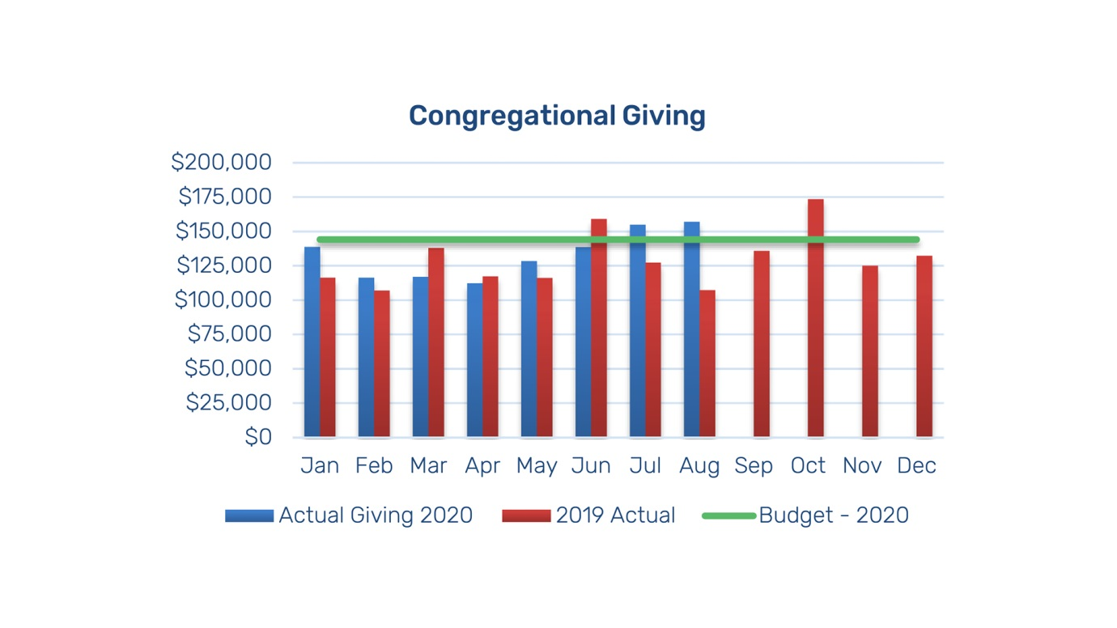

Chart of congregational giving at Trinity Church Adelaide 2020 up to August (data supplied by TCA administration)

On 10 July, his weekly membership email loudly announced ‘We’re back!’ Consonant with the state government’s rules, he invited members of the various congregations to return to public Sunday worship in a staged sequence, beginning with the small Mandarin congregation on 19 July, through to the split 10.30am congregation (because of its size), on 9 and 16 August. Social distancing and all the other rules were to be maintained scrupulously, as Bernie Leo’s teams were learning. Consequently, Church Online would be transmitted at 10.30 only from 23 August, and serve the whole network. So it was a time of rejoicing as those who chose to attend joined in services again on site. After one week of singing loudly unto the Lord, public health officials recommended that this cease, for it posed a risk of infection. Subsequently, Michael Morrow ensured psalms and other texts were said together as an alternative. But there was disappointment too. Distancing limited social interactions at these Sunday services.

Numbers attending the resumed services on North Terrace were significantly down on pre-Covid levels, which had been running around 800 in February. Plainly some people chose not to attend lest they risk infection because they were immunity impaired. Hopefully they will return when they are more confident it is safe to do so. Others found the online services more attractive. Maybe they can be weaned from this this preference to return to the site. Others have left altogether. This was not unexpected. A time of upheaval gave people a chance to reflect on priorities and make changes, for example to a church closer to where they live. It also gave those more on the fringe a chance to sneak away without being noticed: the cover of COVID gave them a five-month head start. This has not been unique to TCA, with observers in England making similar observations. The breach of old routines has affected many. Then there were far fewer international students. At the same time, some have also joined from other churches and from no church at all. In the Covid phase online numbers ran in the low 400s, and then the combined numbers grew for all services at TCA to the mid 500s. But for all that, an attendance of about 100 at first at 9am looked pretty sparse, spread about the church with every other pew roped off. Gradually numbers at all services have begun to recover from these initial lows. Still, Des Smith had to focus on the reality that his membership had contracted, even if it was tighter knit.
But the Covid crisis is by no means over. Trinity Church Adelaide experienced this truth, like everyone else, when on Wednesday 18 November, the SA State Government announced an immediate lockdown for the next six days. In the event, it only lasted for three. But once more Trinity congregations, Bible study groups and all the other activities could not meet. Possibly the most disappointing was the cancellation of that Thursday’s first meeting of the Friendship Service in months.
Again there was a scramble to deliver an online Sunday service at TCA, as for the other network churches, for the coming Sunday. The city team decided this time to present a live feed from the 9am service held in the church without a congregation. This would be repeated for the other time slots on Sunday 22. This was a new challenge. The decision meant an opportunity for the musicians to be back in their accustomed places, which they had long desired. It would be easier to administer, without the calling on a variety of online inputs (readings, prayers, announcements) or the follow-up of editing. The team were keen to explore the method for possible future use to create podcasts of important events. On the negative side, Des Smith would be without his teleprompter, though this proved less obvious because of the distance of the camera from him. He still needed to look down from time to time. Worse was the very noticeable decline in the clarity of the image because of the long distance between the camera on the balcony and the action at the front of the church.
But the congregation dutifully logged in at 9am that Sunday, relieved that the lockdown had been lifted that morning, but aware that the size of the TCA gatherings still precluded face to face meeting. All went well until about the 57th minute when the feed abruptly disappeared. Des was cut off in mid- sentence of his peroration on Isaiah 11. It later transpired that a software failure had occurred as a result of human error. At least the repeats later in the day were not affected.
So for three weeks, TCA was once again on-line, while most other activities zoomed or paused. By 20 December TCA was fully back to face to face activities, still socially distant and carefully managed. Thus, those intending to attend a Christmas service needed to register in advance.
The return to on-line presentation was carried out swiftly and efficiently, with that one failure. Church members accepted the necessity of what had to be done and the church continued its vigorous ministry.
I will conclude this essay with some attempt at overall assessment. It is necessarily provisional, since the pandemic is still very real and will not abate for some considerable time, probably years. The long-term outcomes are by no means clear. On the negative side, time has been lost, for example in promoting the Five Ms as the way the church is mobilised. Momentum for addressing future projects has been put at risk, though the response to the invitation to fund the proposed children’s worker, and the willingness to move to Temple Christian College mentioned below, might suggest otherwise. Significantly, the numbers of those attending were down. Des Smith does not expect the same numbers will apply after it is all over as did last year. What has been gained? As Bernie Leo pointed out, and Smith concurs, the principal gain has been closeness as a church: ‘we have all actually become part of the one gathering. Adversity has brought extra effort. People have been grateful for the effort, even if it is the least we can do, so more unity.’ Smith also suspects that Trinity Adelaide will be a leaner but stronger and more united church. Some hoped-for actions have been brought forward: for example Church in a Box, the greater use of pre-recording, the increased despatch of information online in lieu of Sunday announcements. This means Sunday gatherings won’t be forced to do as much extraneous work as they have been doing. Probably too, more ministry will be carried out in small groups and even face to face, oneanothering. The question of whether a new church can be planted in the near western suburbs has already been raised because of the need to halve the size of the 10.30 congregation meeting on site each week to comply with Covid-safe regulations. Instead of meeting fortnightly, they were asked to indicate willingness to worship at Temple Christian College at Mile End. First responses were encouraging. The first service was held there on 18 October, with 117 attending, including visiting volunteers. In addition, having created an online presence, Trinity Church Online will become permanent as a new church within the Trinity Network. Already Trinity Adelaide has appointed a new children’s worker, Stephen Urmston, to commence in 2021, after the success of a special fundraising appeal for $200,000 in pledges for 2021-22, despite the appearance of hard times. Most important of all, people are still becoming Christians and joining into regular participation in Trinity’s life, and some of them have been baptised (the first at 5pm on 25 October). Overall, Des Smith drew encouragement from St Paul, writing in 2 Timothy (2:19-10): while Paul was in chains, ‘God’s word is not chained’, neither then, nor during the 2020 Covid crisis.
The governance model adopted by Trinity Church Adelaide, is, as we have seen, very top-down and flat, with little use of management by representative committees. Members of the paid staff have areas of responsibility that are clearly defined, deriving from the church’s annual vision and mission statements. Broadly they get on with the job, subject to weekly staff meetings chaired by the senior pastor, along with more occasional strategic planning meetings. There is however a strong culture of reporting back to the congregation, especially these days by email on a weekly basis as well as whenever occasion demands. It is important to recognise also the key roles played by the support staff, whose expertise contributed significantly to the successful execution of the plans developed by the church leaders. This essay has shown that this model of governance, plainly more authoritarian than the usual Anglican arrangements which increasingly possess a significant degree of elected leadership, has proved to be highly effective and responsive to the demands posed by the Covid pandemic. Leadership has been marked by foresight and clarity. The degree of dedication to task, deriving from the shared goals, has been remarkable.

Dr Brian Dickey taught history at Flinders University and is now retired. He has been a member of Trinity Church Adelaide since 1967. He thanks the members of the TCA staff who answered his endless questions, endured his interview technique and generally encouraged him in this project. He is also grateful to the editor, Don Owers, Stuart Piggin and David Hilliard for helpful suggestions.
Abbreviated to TCA according to current usage. This has replaced ‘Holy Trinity Adelaide’, which had been current since the 1950s but not before, as the preferred name.
Brian Dickey, Holy Trinity Adelaide 1836-1988: the history of a city church, Adelaide, Trinity Trust Inc, 1988; ‘Post War Church Dynamics: Holy Trinity, Adelaide 1946-73 as a case study’, Lucas, no. 5, pp. 23-28; Holy Trinity Adelaide 1836-2012: the history of a city church, Adelaide, Trinity Trust Inc, 2013; ‘ “ We wanted the first one to be a winner”: Urban Church Planting and the Origins of Holy Trinity Adelaide: Hills’, in Geoffrey R Treloar and Robert D Linder (eds), Making History for God. Essays in Evangelicalism, Revival and Mission in honour of Stuart Piggin, Sydney, Robert Menzies College, pp.169-194; ‘Metropolitan Church Planting: Holy Trinity Adelaide 2000-2015’, Lucas, ser 2, no. 9, 2015-2016, pp.103-24.
For example, the SA Uniting Church bimonthly New Times Aug-Sep 2020, carries an article on how Pilgrim Church Adelaide responded. My thanks to David Hilliard for this and the next reference.
The sources for this study are interviews with key participants I conducted, email replies to my queries sent to staff and other key people, church communications I have received as a member of the church, and of course my own experience as a participant . I have retained efiles and hard copy. Most f the data gathering was done in August, but I have made some attempt to acknowledge later developments. I am especially grateful to Melissa Piggin for details that carry the record into 2021.
Michael Gladwin explored the story of another major evangelical organisation to an even greater crisis, in his EHA public lecture (on Zoom), 29 October 2020, ‘The Australian Bible Society and the Crisis of War and Pandemic, 1914-1919’, to be published in St Marks Review. His findings are closely congruent with mine.
Holy Trinity Church, Vestry Record Book vol2, SRG 94/A2, State Library of South Australia. For a brief note on the story in Adelaide in 1919, see: https://blogs.adelaide.edu.au/special-collections/2019/07/10/the-great-picnic-100-years-since-the-spanish-flu-in-adelaide/.
For fuller coverage, see ‘Metropolitan Church Planting’, and Holy Trinity Adelaide 1836-2012: the history of a city church, pp. 265-281. While the strong evangelical tradition of the church played a critical role in the church-planting project, I could find little evidence that its response to the Covid crisis could be linked to this theological outlook.
Des Smith to Brian Dickey, 6 October 2020.
There are three sets of pamphlets published by TCA from the late 1950s into the 1960s of complete sermons, mainly by Lance Shilton, then rector, held in State Library of SA and Adelaide Anglican Archives.
Ben Chapman to Brian Dickey, 18 September 2020.
Severe Acute Respiratory Syndrome.
Boon Yong Sim to Brian Dickey, 18 August 2020.
This is the open church program with volunteers welcoming visitors into the church building during the week.
Duncan Ward to Brian Dickey, 17 September 2020.
Dr Sarah Chapman, a specialist working at several private hospitals.
Paul Harrington in conversation with Brian Dickey, 20 August 2020.
Ben Chapman to Brian Dickey 18 September 2020.
James Agnew to Brian Dickey 28 August 2020.
Des Smith in conversation with Brian Dickey, 18 August 2020.
Paul Harrington to Trinity Church Adelaide members, 18 March 2020, and ‘Announcement about Sunday Meetings in light of Covid-19’.
James Agnew to Brian Dickey, 28 August 2020.
Michael Morrow in conversation with Brian Dickey, 12 August 2020. The following paragraphs rely on this conversation.
Paul Harrington to Brian Dickey, 8 October 2020.
A Sony a6600 DSLR camera.
The first service of Holy Communion in the church since lockdown was celebrated on 4 October, with food-safe protocols mandating servers with nitrile gloves and face masks bringing the elements to seated congregants.
Smith’s weekly remarks in his emails to members did however reflect directly on how to respond to the crisis, especially in offering Christian fellowship and support by whatever means.
These remarks are based on the conversation I had with Bernie Leo on 22 September 2020.
He sent another message on 18 March, filling out the pastoral implications for deliberate care and endeavour.
Zoom was first released in 2013, but has mostly become the platform of choice. No one at Trinity knew of it before mid-March.
Bik To to Brian Dickey, 1 September 2020.
Simon Marshman to Brian Dickey, 18 August 2020.
Cathy Sampson to Brian Dickey, 6 September 2020.
Simon Marshman to Brian Dickey, 18 August 2020.
Arthur Ang to Brian Dickey, 21 August 2020, 1 October 2020. Ang maintains detailed records, full of statistics.
Michael Maude, coordinator, to Brian Dickey, 1 October 2020.
The first Covid Safe Instructions were received from the South Australian government in late May.
Zoom is available free for forty-minute sessions, but beyond that requires a monthly or annual fee. Trinity bought two annual licenses, which were mainly used by staff in conference.
Announced in a network-wide message 25 Oct 2020.
Des Smith, weekly email to TCA members, 11 September 2020.
Weekly email to members, 25 September. Attending at Temple College would not be a commitment to the hoped-for church plant in that area, but a possible step in that direction. The first service was held on 18 October.
Data supplied by TCA admin.
Probable details include rostering member churches to provide content, or delivering portions based on excellence; appointing a part time technician to manage recording sessions and editing.

